STATE GOAL
Maine strives to preserve the State’s historic and archaeological resources.
ACKNOWLEDGEMENTS
Plan authors consulted the following resources in preparing this chapter. The comprehensive plan committee did not spend time verifying or documenting the primary sources.
Clifton Historical Society’s booklet “The Reflections of the Past” printed for Clifton’s sesquicentennial celebration in 1998.
Evelyn Huckins manuscript (unpublished) “History of Jarvis Gore and Clifton” dated 1979.
WA Sherman, Superintendent. 1875. Atlas of Penobscot County, Maine. Comstock & Cline, New York.
GEOGRAPHIC FEATURES
Situated in the south central portion of Maine in Penobscot County, the Town of Bradley is the northwestern neighbor; the Town of Eddington sits on the immediate western boundary, the Towns of Dedham and Otis form the southerly bound and the Towns of Amherst and Mariaville bound Clifton to the east. (Map A-1) The landscape is hilly with elevations between 140 (43 m) and 1,152 (351 m) feet above sea level. The lowest elevations (less than 280 (85 m) feet) are in the north-northeastern portion of the Town near Chemo Pond, and account for approximately one-third of the Town’s area. The highest point, Peaked Mountain, stands on the eastern border with Amherst. Most elevations above 700 (213 m) feet are along the Town’s southern and eastern borders.
Although the Town of Clifton is in Penobscot County, Hancock County heavily influenced past development, culture, and the local economy and will continue this influence well into the future. Geological features more closely resemble those of the neighboring communities of Amherst, Aurora and Mariaville: all part of Hancock County.
EARLY SETTLERS
Clifton originally formed part of the post-Revolutionary War township of Jarvis Gore. The name derived from its early landowners, Leonard and Philip Jarvis, who around 1770 began buying lands in what was then the Massachusetts territory of Maine. They continued to do this for some thirty years, purchasing some of their lands from the original grantees and some directly from the Commonwealth of Massachusetts. In February 1794, the General Court of
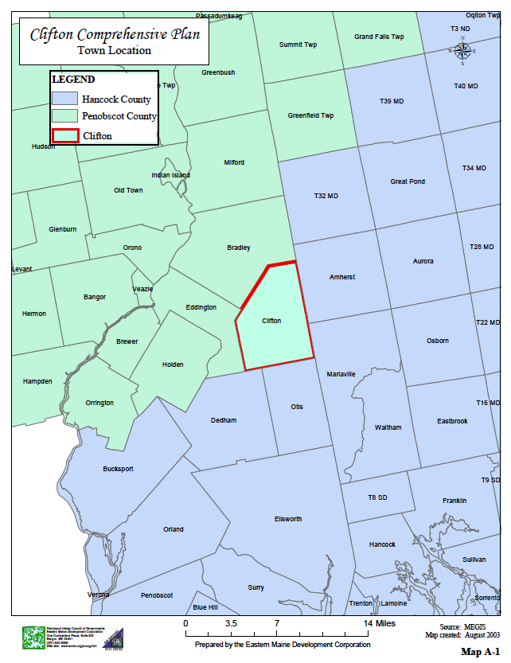
Massachusetts granted Leonard Jarvis a tract containing over 63,000 acres, which included present-day Clifton and Eddington. The Jarvis family never lived in the township; instead they settled in Surry. Around 1800, Philip Jarvis sold out his holdings to Leonard. Historians’ estimates indicate the Jarvis's at one point amassed more than 96,000 acres in Maine, second in size only to the holdings of the Bingham estate.
Workers built the first road through the town around 1800. In 1803 David Cobb, an agent for William Bingham, wrote in a note to Bingham: “...The road from Penobscot River to Mariaville is in constant use by immigrants. This road is the entry port to our lands. Mr. Jarvis through whose land it runs promised to pay his part of [the] expense of making it.” That original road left the present Route 9 at the Bangor Water Road in Eddington and came around the west side of Woodchuck Hill, continued across present-day Route 180 and behind what is now Maplewood Cemetery, passed close by present-day Parks Pond, and then proceeded over Chick Hill to Amherst. It was called Cobbs Great Road. Traces of the old road are still evident, more in some places than in others. Some portions of the old road are still maintained as access trails for snowmobiles and cross-country skiers, ATVs, hikers, and hunters.
By 1810 there were 50 people living in Jarvis Gore (incorporated as a town in 1816); however, not many lived in what is now Clifton. Most people lived in the part that would be incorporated as the Town of Eddington in 1823. In 1816, Benjamin Penny (also spelled Penney) built a log house near the old road behind Maplewood Cemetery. Benjamin Jr. was born in that house in 1818, the first child of European descent born in what is now Clifton. At least four veterans of the War of 1812 moved into the Clifton portion of Jarvis Gore to settle during these years.
Sometime around 1820, a widower from Ireland, Timothy Scott, came across with three of his four children and settled near Chemo Pond. The Scott Point Road is named after him. He is buried in the little cemetery beside this road, which also bears his name.
By 1820 Jarvis Gore had a population of 139 and 50 acres in tillage. Most of the townspeople lived in the section that was annexed to Eddington at its incorporation in 1823. By 1830, what remained of Jarvis Gore (today’s Clifton) was home to 17 families, including Thomas Parks, Sr. (also spelled Parkes), who settled near the pond that today bears his name. Oliver Curt Eddy also established a homestead during the 1830s. He was a veteran of the Black Hawk Indian War who served as a sergeant under Zachary Taylor.
By 1840 the Town became known unofficially as Hillsboro in honor of a distinguished local citizen, Squire Hill; the squire in-turn suggested the name Clifton, for the many prominent cliffs visible throughout the town. The first Annual Town Meeting occured in 1842. The town officially incorporated first as Maine in 1848, then as Clifton in 1849. In 1840 the population was 185, with 27 families in residence. By 1850 the number grew to 50 families, many of whose names are familiar since their descendants still live in Clifton: Campbell, Williams, Jellison, Gusha, Penny/Penney, Chick, Eddy, Orcutt, DeBeck, Sebley, and Davis.
From 1860 to 1920, the community developed and thrived. During its heyday, Clifton had a prosperous rural economy that included small shops and a general store, a post office, five school houses, three churches, three cemeteries plus one hearse house with a horse-drawn hearse, and even a crank-action movie theater during the first few decades of the 20th century. The resident population peaked in 1880 at 350 people, but then slowly declined in each successive decade before hitting a low point of 156 in 1930.
EARLY INDUSTRIES/OCCUPATIONS
As Written by Evelyn Huckins and printed in Clifton Historical Society’s booklet “The Reflections of the Past”
“Saw mills have been popular in the history of this town. Rosalie Wood told me that an early mill was an up-and-down sawmill built by Sylvanus Hammond on the stream below his house (he built the house where Phillip Bragg lived). It must have been built in the 1840-1856, as he died in 1856. One of the first sawmills was on the “Mill Road” run by Luther and Benjamin Penney. They manufactured shingles, long lumber, laths and clapboards. It was run by waterpower. Later they sawed out old-fashioned blueberry boxes, which held about 2 quarts.
Another early mill was built on the brook just below where Dale Green lives now. That was a shingle mill run by Frank Penney. His brother (or cousin) William was the shingle buncher. There have been several mills powered by steam in later years. One was built by L.J. Penney and one by W.F. Chute near Clifton corner. Frank McLaughlin built the mill opposite his house in 1904, which he ran as a long lumber mill and later as a novelty mill. I remember Neal McLaughlin was running it when I was first married and I worked in it for a short time. He was making cue sticks and beautiful trays.
Earl Campbell built a diesel-powered mill in later years. It ran for approximately 40 years when he gave it up in 1965. A mill was started and ran, I believe, by steam. “Pete” Kaslaskas, who now was in Amherst, ran it. It was built in Mrs. Walker’s field. R. Leon Williams started a mill in 1956 and had been adding to it almost every year. It has had several fires but has been built back again, better than before.”
“Frank Penny was the inventor of the “Dingo” shingle machine, sometimes called the “Penny Machine.””
“In 1891, the town offered C. F. Archer a 10 year abatement on his taxes, if he’d build a new sawmill. We know that in 1903, he owned a saw mill.”
Parks Pond Campground stands today on the site of Earl Campbell’s diesel powered mill. It was previously owned and operated by Earl’s granddaughter, Barbara Moore and is now owned by Mike Lufkin..
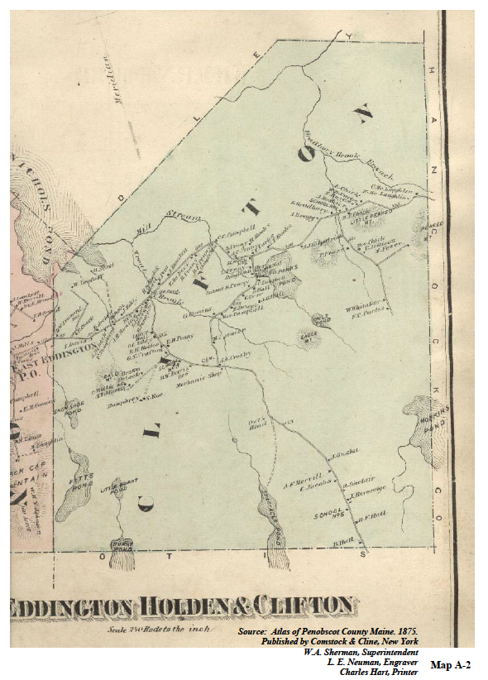
SCHOOLS
In 1863, there were four school districts plus a fifth district in 1868. School #1 sat the foot of Chick Hill, School #2 (Roosevelt School) was near Parks Pond, School #3 (Harold Allen School) sat at the intersection of Route 9 and Rebel Hill Road, School #4 sat near where Maplewood Cemetery currently is and School #5 was at the top of Rebel Hill. Each district had their own agent and each agent hired their own teachers. Each year the Town voted on which district would have summer or winter sessions and how long, by 6 or 8 weeks. By 1900, a Superintendent of Schools had rule over this.
Two of the original school buildings still stand in town. One is the Harold Allen School, standing at 15 Rebel Hill Road and owned by the Clifton Historical Society, serving as a museum and meeting place. The other is the Roosevelt School building located at 743 Airline Road, now a private home.
The School District System ended in 1894 and the Town system commenced until 1966 when the town, in cooperation with Eddington and Holden, formed Maine School Administrative District (MSAD) #63. Today there are no public schools located in the Town of Clifton. The Town is part of Regional School Unit (RSU) #63 along with the neighboring communities of Eddington and Holden. Students attend Eddington Elementary School for grades K – 2, Holden Elementary School for grades 3 - 4 , and the Holbrook Middle School in Holden for grades 5 - 8. High School students have their choice of high schools.
POST OFFICE
Clifton established a Post Office in 1868. This Post Office occupied space at the Moses Chick General Store on the corner of Route 180 and Route 9. In response to the declining population and economy, the Clifton Post Office closed down for the entire month of January in 1928, reestablished February 1, 1928 and then was permanently discontinued on March 15, 1930. From 1930 to the 1980s mail delivery switched back and forth between the towns of Holden and Eddington. Eddington Post Office was responsible for mail delivery from the 1980s until the early 2000s. Since the early 2000s, the Brewer Post Office has been responsible for Clifton’s mail delivery.
CHURCHES
At one time there were three churches in the Town of Clifton; the Calvinistic Baptist, Christian Societies and Freewill Baptist Church. In 1890 the Freewill Baptist Church changed its name to United Baptist Church. On November 19, 1838, the Free Will Baptist Church became the first church to be organized in the township. In 1918, the Church’s name was again changed to Clifton United Baptist Church and it continues to serve Clifton residents today. For many years, it has been the only organized church in the Town.
CAVES
With all the exposed rock within the Town of Clifton, comes the possibility of caves. There are two (2) caves known to exist in the Parks Pond and Peaked Mountain areas. It is not known if Native Americans ever used these caves.
CEMETERIES
The 1875 map of the Map A-2 shows the location of the Town’s cemeteries.
Veterans of many of this nation's wars are buried in Clifton cemeteries. The Town does not have an inventory of veterans who served in World War II, the Korean Conflict, the Vietnam War, the Gulf War or the Iraqi Freedom effort. Each year the Veterans’ gravestones are decorated with little flags for Memorial Day, sometimes through the town coffers and sometimes through the efforts of private citizens -- but every year the flags fly to honor those who sacrificed for our nation (need to validate). Since the early 1950’s flags have been provided by and dispersed by R. Leon Williams and his family. It is not known if R. Leon started this tradition or if he carried it on from his parents. It probably began in honor of his grandfather, Melvin S. Jellison, who was a civil war veteran.
Mount Pleasant Cemetery
In 1879, the Town bought a private family cemetery along what is currently State Route 9 and named it Mount Pleasant Cemetery in 1880. Five Civil War Veterans are buried in this cemetery. The oldest grave located in Mount Pleasant Cemetery is that of Zebulon Parkes, buried on July 29, 1828.
Maplewood Cemetery (Mount Waldo Cemetery)
In 1892, the Town bought a cemetery along what is now State Route 180 and enough land to enlarge it. The Cemetery was called Mount Waldo Cemetery until 1927, when the name was changed to Maplewood Cemetery. The oldest grave in Clifton is located in Maplewood Cemetery and is that of Abigail Crosby who died in 1836 at the age of 84.
Veterans buried in this cemetery include one from the Black Hawk Indian War, two from the War of 1812, thirteen Civil War veterans, one from the Spanish-American War, and fifteen from World War I [as of 1979].
Scott Cemetery
Scott Cemetery is located on the Scott Point Road holding most of the Scott family. In 1894, the Town accepted the deed. The oldest grave in the Scott Cemetery belongs to Augusta Scott, daughter of Daniel Scott Senior, who died at the age of 17 in 1863. The Scott Cemetery is no longer in use by the town and there are no future burial plots. There are 8 Scott family plots and six Tompkins family plots and two other unnamed plots containing infants.
Cemetery Committee
The Town of Clifton's Cemetery Committee has day-to-day oversight authority over the Town's cemeteries and is responsible for enforcing all applicable ordinances, rules, and regulations regarding the cemetery's maintenance and use. The Select Board is responsible for developing ordinances and amendments while the committee is responsible for writing any implementing rules. The Select Board sets the prices for the plots.
The Cemetery Committee places flags on Veteran graves just prior to Memorial Day each year. The Williams family used to perform this activity and it is unclear when the transition occurred.

TOWN GOVERNMENT
The Town of Clifton established in 1816, and did not incorporate as a Town until 1848 with the name of Maine. The Town’s name changed to Clifton in 1849. Although the first town meeting was held in 1842, the earliest records only start in 1863. Town business operated out of the homes of the Town Clerks until the mid-1990s, when the woodshed of the Harold Allen School was used as the Town Office. This office was used, with no running water, until 1998 when the town built the current municipal building on Airline Road near the old Leo Williams Mill site and Eddington town line. A decade that began with the Town’s business being transacted in a number of private kitchens and living rooms ended with all the records and personnel under one roof!
In the 1950s and 1960s the primary town officers were the selectmen/assessors (3 members), town clerk, and treasurer. Currently, the selectmen (5 members elected to three-year terms), administrative assistant, assessor’s agent, planning board (5 members appointed to three-year terms), and code enforcement officer oversee town business.
HISTORIC RESOURCES
Clifton Historical Society
The Town of Clifton celebrated its sesquicentennial in 1998. The Clifton Historical Society, which was established in 1993, organized the festivities. This group of committed volunteers has worked tirelessly to help retain a living sense of Clifton’s past through the collected stories and donated items of lifelong residents. In 2000 the Town of Clifton sold the former Harold Allen School building at Clifton Corners (which previously housed the Town Office and Clifton Library), the Town Hall and Hearse to the Clifton Historical Society for $1.00 each, in order to provide a meeting space for the group and a museum for the public.
Maine Historic Preservation Commission
Established through a legislative act in 1971, the Maine Historic Preservation Commission (MHPC) is the state functioning as the State Historic Preservation Office in Maine. As such, the Commission is responsible for the identification, evaluation, and protection of Maine’s significant cultural resources as directed by the National Historic Preservation Act of 1966. The Commission oversees the statewide survey program, nominates properties to the National Register of Historic Places, reviews development activities for their effect on cultural resources, co-ordinates rehabilitation projects under the Preservation Tax Incentives Program, assists local governments in survey work and the design of preservation guidelines, and is involved in a variety of public education activities.
National Register of Historic Places
The National Register of Historic Places (NRHP) is the official list of the Nation’s cultural resources worthy of preservation that are significant in American history, architecture, archaeology, engineering, and culture. Authorized under the National Register Preservation Act of 1966, the National Register is part of a national program to coordinate and support public and private efforts to identify, evaluate, and protect our historic and archaeological resources. The National Register is administered by the National Park Service under the Secretary of the Interior. Properties are listed for their importance in American history, architecture, archaeology, engineering, and culture. These resources contribute to an understanding of the historical and cultural foundation of the nation. Listing in the National Register signifies:
- recognition that a property is of significance to the nation, the state, and the community;
- consideration in the planning for federal or federally assisted projects;
- eligibility for federal tax benefits; and
- qualifications for federal assistance for historic preservation, when funds are available.
Maine Memory Network
The Maine Memory Network is a statewide digital museum and archive developed and maintained by the Maine Historical Society. This website provides educators, students, and the general public with unprecedented access to historical collections throughout Maine. The Network enables organizations in communities across the state to upload and manage digital copies of artifacts, images, and documents from their collections into one centralized, web-accessible database.
Evelyn Huckins History of Jarvis Gore and Clifton
Evelyn Huckins was a school teacher and resident of Clifton (1908-1985) who became housebound in her later years of life. She chose to use her time to create, in handwritten notebooks, a history of Jarvis Gore and Clifton, using old records and her memories. Her "History" was completed in 1979 and is an assorted collection of material. Although it would require much more research and documentation to verify the accuracy and completeness of all its material, it is an interesting introduction to anyone who wants to start research into Clifton history. Some of the references she makes can start one on a journey of historical research, and some of the information is probably not verifiable, as some records may not exist.
ARCHAEOLOGICAL RESOURCES
Prehistoric Archaeological Sites
The Maine Historic Preservation Commission reports there are no known prehistoric archaeological sites in the Town of Clifton. This may be due to the lack of conduct of an archaeological survey. In particular, the Chemo Pond shoreline and shorelines of some of the smaller lakes in Clifton could benefit from a prehistoric archeological survey.
Historic Archaeological Sites
Leith Smith of the Maine Historic Preservation Commission reports that there is one known historic archeological site in town. Known to MHPC as the Hepsibeth Debeck site, it is a farmstead demonstrating a period of significance circa 1866-1900. No town-wide professional surveys for historic archaeological sites have been conducted to date in Clifton. Future archaeological surveys should focus on the identification of potentially significant resources associated with the town’s agricultural, residential, and industrial heritage, particularly those associated with the earliest Euro-American settlement of the town in the 18th and 19th centuries.

HISTORIC BUILDINGS/STRUCTURES/OBJECTS
Kirk Mahoney of the Maine Historic Preservation Commission reports there are two properties in Clifton currently listed in the National Register of Historic Places; Cliffwood Hall and the Harold Allan Schoolhouse, both located at 15 Rebel Hill Road. A comprehensive survey of Clifton’s above-ground resources may identify additional properties eligible for nomination to the National Register of Historic Places.
BUILDINGS WITH LOCAL HISTORICAL SIGNIFICANCE
Hearse House
In 1882, the Town voted to buy a hearse and build a hearse house. The house was to be 14 feet wide and 22 feet long. In 1904, the hearse needed repair, and the townspeople voted not to repair it and bought a new hearse in 1907. Although the Historical Society had hopes of restoring the Hearse House, they were not able to raise funds and the Hearse House succumbed to demolition.
Chick House
The Chick House, located on the corner of Route 180, may be the oldest house in Clifton because tax records indicate it was built in 1782. Due to extensive deterioration from water leaks the building was demolished.
Town Hall
In 1892, the “Band of Willing Workers Society” built a two-story 30 x 48 foot building on a one-half acre lot on “Otis Road”, (now known as the Rebel Hill road), as a hall to hold entertainment and socials. The hall was dedicated on June 6, 1892, and named Cliffwood Hall. It became the Town Hall in 1899, when the Town bought the hall complete with stoves, chairs, oil lamps, piano, silverware and dishes, and tables to seat 100 people. The upstairs hosted a wooden basketball court. In 1912, people relocated School #3, the Harold Allen School to the Town Hall lot. In the mid 1980s, the Town had made improvements to the woodshed of the Harold Allan School. This 10’ x 14’ room functioned as the Town Office for board meetings. Clifton began to consider future options and on March 18, 1991, voters designated tax map 7, lot 4, (on Route 9) as the future home of Clifton’s municipal building and raised $500 for initial planning of the project. The parcel is slightly larger than 56-acres and carries the local name of the “Spencer lot,” named after Herbert Spencer, who gifted the property to the Town in the 1930s. In 1992, voters started appropriating a capital reserve account for the project.
By the late 1990s, it became clear to all, Clifton was no longer able to conduct business in the fine and historic old Town Hall where, for the past 100 years, voters waded through the March mud and slush to gather on wooden benches (those near the wood stove baking, those back by the door feeling the cold drafts) to execute the town’s warrant for another year. In 1995, the Office started having hours for a Town Manager who served also as Clerk and Tax Collector. Since there was no running water, the Town installed an electric toilet. Clifton residents recognized the need to renovate or replace the Town Hall and Town Office.
The Select Board formed and appointed a Municipal Building Committee in 1995. In December 1998 construction of the building began. The new Town Office ceremoniously opened in April of 1999. The cost of the municipal building project was $196,160.05. The Town raised the sum by combining $57,500 plus $10,089 interest from the capital reserve, $31,173 from harvesting the town lot, $71,531 from selling tax acquired properties, and a $30,000, 30-month loan. The Municipal Building is 100% handicap accessible and has a parking area with a paved surface. Upon completion of the municipal building project, $6,099 remained in the fund. Some of this money went towards a flagpole, building ramps at the three entrances of the building, fabricating a window between the clerk’s offices and improving lighting in the Town Meeting Room. In 2001, the addition of a second streetlight allowed both the driveway entrance and the parking area to be adequately illuminated. A security light from the sand shed illuminates the rear of the building at night.
Thus, the end of the decade – and the millennium – came with evolution governing and administering Clifton.
Roosevelt School
Situated on the corner of Mill Lane and bounded by the cemetery was Parkes School (#2), later called Roosevelt School built in 1854. The town and school system moved the structure to its present site, across from the Baptist Church in 1923. Sold in 1973 and it is now a private residence.
Harold Allen School
School #3 - now called the Harold Allen School – relocated to the Town Hall Lot in 1912. It now belongs to the Clifton Historical Society and serves as their meeting place and part of their museum.
Other buildings with local historical significance
There are other buildings still existing today presented on the 1875 map warranting research for historical significance. Tax records indicate construction of these buildings prior to 1900. There may be other structures over 100 years old within the town and the tax records simply do not specify their year of construction.
THREATS TO HISTORIC AND ARCHAEOLOGICAL RESOURCES
The town (or state or federal) government must first identify historical and archaeological resources before they protection from any potential threats. Protection of identified historic sites in Clifton is the responsibility of the municipality or individual owners of the site(s). Archaeological resources are often under threat by development because their existence is not obvious. Public ownership of historic sites is an option only if the owners desire to sell their property and the public supports its acquisition and maintenance.
RESOURCE PROTECTION MEASURES
Maine Historic Preservation Commission
The MHPC is the central repository in the state for archeological and historic buildings survey information. Survey files include computer files, map sets, paper data forms, field notes, unpublished reports, photographic archives and published works. Archeological files are exempt from the “right to know” legislation and are accessible only with permission from MHPC staff, to protect sensitive archaeological sites and landowners’ privacy. Summaries of sensitive archaeological information available on a case-by-case basis.
The MHPC contains an inventory of sites, yet has no jurisdiction over these sites. The MHPC coordinates funding for inventory and restoration of historic sites. Towns with historic protection ordinances may also be eligible for monies or other assistance through MHPC. Funding for inventory and restoration is (sometimes) available depending on legislative appropriation.
National Register of Historic Places
MHPC also coordinates through the National Register of Historic Places. Sites registered by the owner with the National Register of Historic Places enjoy protection through federal legislation only from intervention or development by a federal agency. Listing a property on the National Register provides protection only when federal funds are used for a project, which would affect the historic property. Only a local ordinance will provide protection of historic resources.
Local Ordinances
Locally adopted ordinances, such as land use and subdivision ordinances can protect historic area zones from harmful impact and regulate their development. Currently, Clifton very minimally protects historic resources.
Shoreland Zoning Ordinance
Frequently, archaeological sites occur along shores (99% of Maine's known prehistoric archaeological sites are located near water), thus, shoreland zoning often provides protection of such sites. To the extent people identify archaeological sites in the future on the banks of water bodies within the community, shoreland zoning affords some protections.
The Site Location Law
The law requires consideration of impact on historic resources. There is no history of any development in Clifton requiring implementation of the Site Location of Development Act in order to receive approval other than the Pisgah Mountain Wind Energy Project.
Easement and Initiatives
Individual landowners, historic societies, or nonprofit agencies may apply a number of development restrictions to their properties on a voluntary basis. Enforcement would occur through deed covenants or restrictive easements.
Public or Nonprofit Ownership
Public ownership of historic resources is another option for protection of historic buildings or sites. For example, the Clifton Historical Society owns the former Town Hall site.

ANALYSIS
Trends
People continue to live and re-develop essentially the same areas in the community. In recent years, there has been a slight increase in development (individual homes) on some of the high hills in the town as well as the identification of portions Clifton as being a high value wind energy resource area on national maps resulting in a small wind energy project (five turbines with another 5 to be soon installed). Other chapters discuss this last component in greater detail.
Protective Measures
There are no detailed specific protections for historic resources at the local level.
Clifton Land Use Ordinance (CLUO)
Article 3 of the Land Use Ordinance (2017) establishes growth management areas. The ordinance lists the area identified as GMA 1A as “the traditional core of the community with the historically oldest settlement and the most diverse existing development pattern.” Furthermore, shoreland zoning lists protection of archaeological and historic resources as a goal.
Article 6 of the CLUO contains submission requirements for subdivisions and site plans. For larger subdivisions and more complex site plans, the CLUO requires submission of impact on archaeological and historic resources. Performance standards listed in Article 7 require the following under GPS 2.0:
Any proposed land use activity involving structural development or soil disturbance on or adjacent to sites listed on, or eligible to be listed on the National Register of Historic Places, as determined by the Planning Board shall be submitted by the applicant to the Maine Historic Preservation Commission for review and comment, at least twenty (20) days prior to action being taken by the Planning Board. The Planning Board shall consider comments received from the Commission prior to rendering a decision on the application.
There are no specific prohibitions currently in the development criteria though there is a requirement to discuss impact mitigation.
Local Historic Preservation Sustainment
The Clifton Historical Society is active and fund raises from private resources. Generally a small amount of money from the town budget goes to the Historical Society annually – less than $800. In general, the wider public is not aggressively promoting preservation of these resources. Alternately, there is a core group of people who actively manage documentation and maintenance of the museum and other information of interest. They maintain a website at the following web address: http://cliftonhs.mainememory.net/page/2075/display.html.
Another sustainment activity would be updating the veteran register for the cemeteries. The latest inventory of veterans buried in the cemeteries is from 1979.

POLICIES AND IMPLEMENTATION STRATEGIES
The Select and Planning Boards will continue to provide support, oversight and improvement to the inventory, maintenance, and protection of archaeological and historic resources including land, artifacts, and documents. Specifically, the Boards will continue to work with the privately operated Clifton Historical Society on an as needed basis. The Town does not have a public location to safely store and exhibit artifacts and thus, the Historical Society will be the curator authority for such items.
The Planning Board will continue to ensure adequate submission of information and appropriate mitigation when necessary for future development within the jurisdiction of the Board. The Planning Board will continue to review the Land Use Ordinance and support the submission and performance requirements approved by the voters. Town officials will make available to any interested parties information that they may possess regarding grants and other resources useful to support historical preservation.

