STATE GOAL
Maine strives to:
safeguard the State’s agricultural and forest resources from development which threatens those resources;
protect the State’s other critical natural resources, including without limitation, wetlands, wildlife and fisheries habitat, sand dunes, shorelands, scenic vistas and unique natural areas.
FOREST, AGRICULTURAL, and OTHER NATURAL RESOURCES
- In rural Maine communities, it is nearly impossible to segregate or separate these land use topics and in fact, their integration is critical to maintain the vitality, character, culture, and social fabric in the community. The public opinion survey indicates a very strong majority of people (whether they are strong land rights advocates or strong land preservation advocates) in Clifton value natural resources.
At times how humans interact or desire to interact creates conflict since sometimes use of these resources for one practice precludes use of the resources for alternate practices. Alternately, sometimes use of the resources for one practice creates the perception if not the illusion of exclusion. For this reason, it’s critical the Town officials sustain contact with the residents to ensure the plans and actions are consistent and well known. As people come and go, there should be an expectation the culture will shift over time; this means being open to non-attribution discussion of opinions of past practices or events. Because the impacts are long lasting, the Town must responsibly and equitably develop and articulate resource management plans with a strategic long-range perspective – as in thirty to fifty years.
Forest, agricultural and other natural resources information is useful in identifying opportunities and constraints for development and for protecting environmentally sensitive areas. Clifton is a typical rural Maine town and the natural resources contribute greatly to the quality of life. Water pollution, high cost and maintenance of public services, and the destruction of existing wildlife and scenic values are just a few of the existing ways that a community ends up paying for improper land use; therefore, it is extremely important to identify and protect these areas.
Forest and agriculture and other natural resources include the topography, land cover, and wildlife of Clifton. Forestry and agricultural practices play a much larger role in Clifton than other land development since over the past 12 years, almost no development occurred. Pisgah Mountain Wind Energy, a towing business, and a small engine repair business were the only new commercial development. One subdivision occurred on Route 180; all the lots were large and it was outside any significant water resources. Several people converted their water front properties from seasonal to year around. Typically this results in improved conditions as discussed in the Water Resources chapter.
Natural resources information, like water resources information, is useful in identifying opportunities and constraints for development and corresponding needs for protecting sensitive areas. The Town protects natural resources via the Clifton Land Use Ordinance (CLUO). For many years Clifton had a stand alone Shoreland Zoning Ordinance first adopted in 1992; amended multiple times over the past 20 years, the current regulations are within the 2017 CLUO. The information contained herein is for reference only; for official and enforceable regulations (and locations), refer to the most current version of the CLUO.
LEGAL FRAMEWORK
The Maine Forest Practices Act
This act, though initially focused on liquidation harvesting (aka clear cutting), provides a comprehensive framework for forest practices from management to cutting proximate to water resources to forest road construction. There is also the opportunity to develop local forest harvesting regulations, which Clifton did not choose to do when this opportunity became available. This would be potentially a costly endeavor should Clifton decide to adopt the regulations because it would imply enforcement. A more complete listing of Forestry laws and rules and their impact is available on the Department of Agriculture, Conservation, and Forestry website.
The Maine Agriculture Protection Act
In general, this act directs towns to consult with the agricultural commissioner before enacting ordinances. A municipality must provide the commissioner with a copy of any proposed ordinance that affects farm operations. The clerk of the municipality or a municipal official designated by the clerk shall submit a copy of the proposed ordinance to the commissioner at least 90 days prior to the meeting of the legislative body or public hearing at which adoption of the ordinance will be considered. The commissioner shall review the proposed ordinance and advise the municipality as to whether the proposed ordinance restricts or prohibits the use of generally accepted agricultural practices. This section does not affect municipal authority to enact ordinances. That said, towns cannot cite farmers for being in violation of an ordinance for performing generally accepted agricultural practices on areas zoned for agriculture. A more complete listing of Farmland laws and rules and their impact is available on the Department of Agriculture, Conservation, and Forestry website.
The (Maine) Natural Resources Protection Act
The Natural Resources Protection Act (NRPA) establishes a permit review process designed to provide protection of natural resources of statewide importance. The Act applies to the following protected natural resources: coastal wetlands and sand dunes; freshwater wetlands; great ponds; rivers, streams and brooks; fragile mountain areas, and significant wildlife habitat. The NRPA recognizes the State significance of these natural resources in terms of their recreational, historical, and environmental value to present and future generations. The NRPA’s intent is to prevent any unreasonable impact to, degradation of or destruction of the resources and to encourage their protection or enhancement. Nearly all Maine laws protecting natural resources flow from this act and the Maine Department of Environmental Protection is the oversight agency at state level.

GEOGRAPHIC LOCATION and TOPOGRAPHY
The Town of Clifton is relatively small, approximately 21,800 acres. A majority of Clifton’s landmass consists of undeveloped natural areas, water bodies, streams and related wetlands. The landscape of Clifton is hilly with elevations between 140 and 1,152 feet above sea level. The lowest elevations (less than 280 feet) are in the north-northeastern portion of the town near Chemo Pond, and account for approximately one third of the Town’s area. The highest point, Peaked Mountain, rests on the eastern border with Amherst. Most elevations above 700 feet are along the Town’s southern and eastern borders. These same areas contain many slopes of 15 % or more, making a large portion of this section of town challenging for intensive development and potentially more valuable as a natural resource. The table below shows well-known peaks, elevations, and cardinal quadrant locations in the town.
- Mountain | - Elevation (FT ASL) | - Location
- Woodchuck Hill | - 834 | - SW
- Pisgah Mountain | - 791 | - S
- Eagle Bluff | - 700 | - E
- Parks Pond Bluff | - 660 | - E
- Little Peaked Mountain | - 900 | - E
- Peaked Mountain | - 1,152 | - E
Source: United States Geological Survey Topographic Maps
SOILS
- Soils influence a community in many ways. They impact the viability of agriculture, forestry, and other natural resource industries. They are a factor in determining wildlife habitats and influence the type of development, which can take place. The various soil characteristics present several different limitations to development, which can often be overcome through special design, construction, and planning.
- The United States Department of Agriculture (USDA) Soil and Water Conservation District (SWCD) prepared soil classification maps by county for the State of Maine. Land suitability analysis or soil surveys are useful to produce maps depicting the appropriateness of land areas to various land uses. The survey consists of an inventory, description, and evaluation of the soils within each county. The survey classifies all soils within a county into soil series. The classification is based on characteristics of the soil, including texture (percentage of sand, silt, clay), permeability, slope, wetness, and so on. The Clifton portion of the Penobscot County soil survey map and interpretations of the soil survey can provide information on potential ratings reflecting the potential use rather than the limitations of use.
Soils influence a community in many ways. They impact the viability of agriculture, forestry, and other natural resource industries. They are a factor in determining wildlife habitats and influence the type of development, which can take place. The various soil characteristics present several different limitations to development, which can often be overcome through special design, construction, and planning.
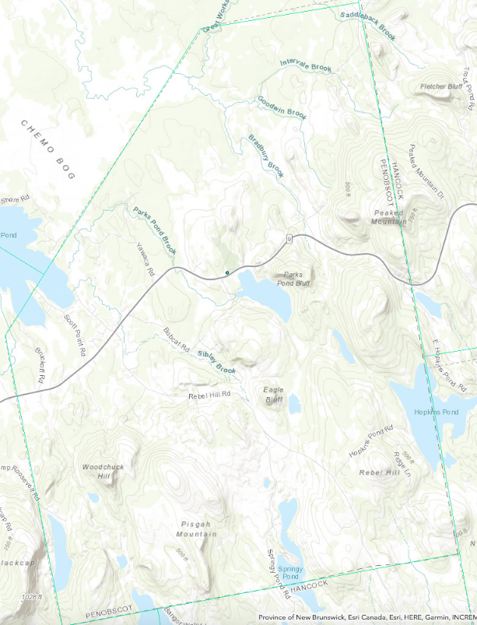
Several soil characteristics can present challenges to land development, including shallow depth to bedrock, shallow depth to water table, flooding potential, and high erosion potential. Consequences from improper development in these soil conditions can include damage to personal property resulting from erosion and flooding, contamination of groundwater from septic systems, and adverse impacts to surface water quality from sedimentation. Soils with a fluctuating water table and frost heaving, for example, may damage roads and buildings that are constructed in an area where those soils are present.
Source: ESRI USGS Topography
Poorly drained soils have less than 7” to water table and usually place severe limitations on land development. Somewhat poorly drained soils have 7” to 16” to water table. Moderately well drained soils have 16” to 40” to water table and have moderate limitations to development, while well-drained soils with over 40” to water table have few, if any, limitations.
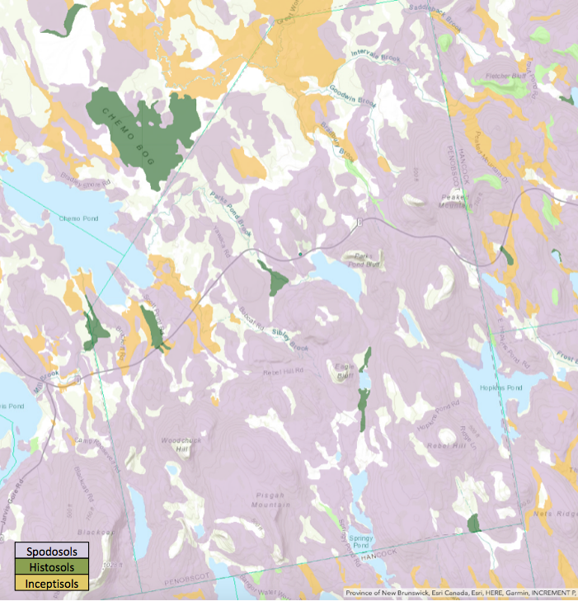
Source: ESRI North American Soil Layers
Three major orders of soil exist in Clifton. They are: Spodosols (most of the town); small portions of Inceptisols and Histosols. Spodosols are acid soils characterized by a subsurface accumulation of humus and Al & Fe oxides. These soils are very photogenic and typically have a light-colored E horizon overlying a reddish-brown spodic horizon. Spodosols often occur under coniferous forest in cool, moist climates. Inceptisols are a soil order in USDA soil taxonomy. They form quickly through alteration of parent material. They have no accumulation of clays, iron oxide, aluminum oxide or organic matter. They have an ochric or umbric horizon and a cambic subsurface horizon.
Histosols form whenever organic matter forms at a more rapid rate than it is destroyed. This occurs because of restricted drainage precluding aerobic decomposition, and the remains of plants and animals remain within the soil. Thus, Histosols are very important ecologically because they, and Gelisols (fragile arctic soils), store large quantities of organic carbon. If accumulation continues for a long enough period, coal forms. Histosols are generally very difficult to cultivate because of the poor drainage and often low chemical fertility. However, Histosols formed on very recent glacial lands (like Clifton) can often be very productive when drained and produce high-grade pasture for dairying or beef cattle. They can sometimes be used for fruit if carefully managed, but there is a great risk of the organic matter becoming dry powder and eroding under the influence of drying winds. A tendency towards shrinkage and compaction is also evident with crops. Histosols have greatly restricted use for civil engineering purposes because heavy structures tend to sink in the wet soil.
Highlights of some soils at the more specific classification level include discussion of several groups. The Rockland-Canaan (Spodosol) soil association covers a large portion of Clifton. These soils have moderately high runoff potential when drained and high runoff potential when saturated. The Hermon-Brayton-Monadnock (Spodosol) soil association is the second most common soil type in Clifton and occurs at most of the town’s higher elevations. This soil association also occurs in dense, deep glacial till and typically forms along the sides and base of glaciated slopes.
Scantic-Buxton-Biddeford (Inceptisols) silt-loam soil associations follow the northern diagonal corner of Clifton, in the vicinity of Great Works Stream and Intervale Brook where there is not muck. This association forms in deep and compacted glacial till on glaciated uplands. The Plaisted-Monarda-Burnham soil association is located along the middle of the northern diagonal border with Bradley. This association forms in deep and compacted glacial till on glaciated uplands. The Plaisted series consists of very deep, well-drained soils on drumlins and till ridges. The Monarda series consists of poorly drained soils formed in dense till on lower slopes or in slight depressions on till plains. They are very deep to bedrock and shallow to dense till. The Burnham series consists of very deep, very poorly drained soils in depressions on glaciated uplands. These soils formed in dense glacial till. Slope ranges from 0 to 3 percent.
The Colton-Adams-Lamoine (Spodosols) soil association surrounds Springy Pond at the southern border of Clifton with Otis. This soil association is a very deep silt-sand outwash soil, typically found along eskers and glaciated terraces. With the exception of the peat deposits along Chemo Pond near the Bradley border, the soil associations found in Clifton do not in themselves present major roadblocks to development. Frost heave is very common in dense glacial tills, but there are standard construction techniques for road building and structural foundations that tend to reduce or eliminate the problem.
STEEP SLOPES
Slope is one of the most noticeable of limiting factors in Clifton. It is a major component of the landscape and is one of the most significant geological properties governing land use. Most land use and development takes place on the less sloping areas, areas with slopes of less than 15 percent (representing an average drop of 15 feet or more in 100 feet horizontal distance). On steep slopes, areas with slopes of 15 percent or more, soils present problems for buildings, roads, and septic systems. The costs of engineering foundations and installing septic or sewer and other utility systems increase.
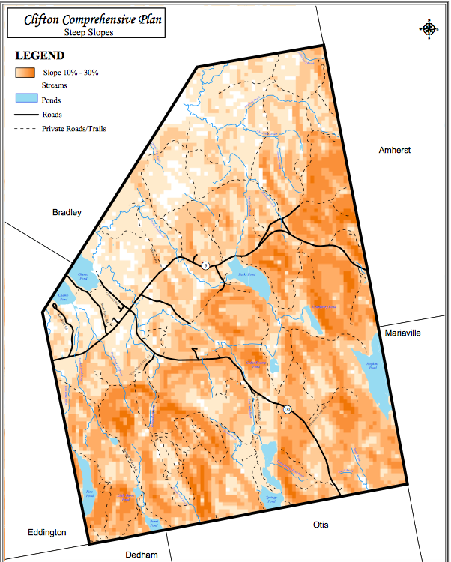
The Steep Slopes Map provides some readily available information on the location of steep slopes in Clifton. Slopes greater than 15% grade preclude extensive development because of problems with erosion, runoff, and construction limitations such as allowable road grades, suitability for septic sewage disposal, and stability of foundations. Steep slopes (15 percent or more) are common throughout the entire town and represent a significant factor in limiting development. These areas often associate with elevations greater than or equal to 700 feet, which occupy much of the southern half, and eastern border of Clifton. Permits for developing on properties with slopes between 15% and 20% should occur after ensuring proper planning and execution of controls to address issues of water run-off.

FORESTS
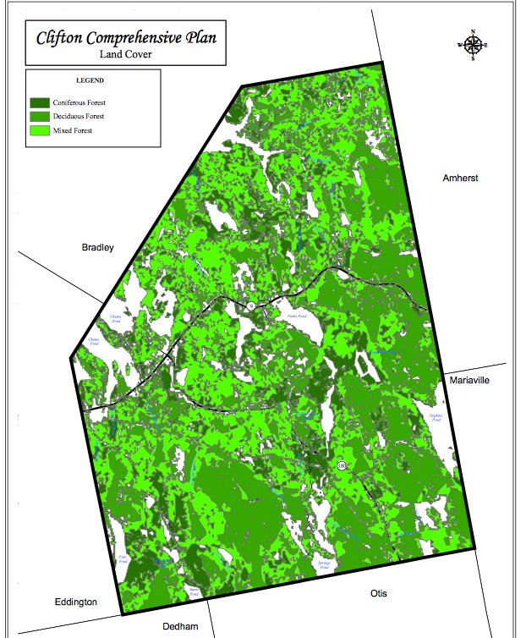
The forests of Maine are mostly third- and fourth- generation timber stands from forests virgin to human impact. Forested lands supply job opportunities while also harboring a diverse array of wildlife. Many forested areas are critical links in the survival of important land and aquatic species. For generations, Mainers pursued recreational opportunities and sought solitude in privately owned, yet quasi-public woodlands. Overall, timber harvesting is down in Maine. Most telling is the percentage of the state clear cut – about 45% in 1989 versus 6% in 2015 according to the Maine Forest Service.
AGRICULTURE
The land in Clifton is not well suited for high-yield agriculture, being primarily a dense glacial till filled with rock sizes ranging from cobbles to huge boulders. Many people have family garden plots and some keep a few hens or other livestock; the only commercial scale agricultural activities are blueberry barrens and a nursery/greenhouse specializing in perennial plants and wholesale organic vegetables.
While some landowners maintain large open fields, they are not currently being harvested for hay. In the past, some Clifton residents maintained orchards and kept small fruit stands. The future land use plan should consider including some blueberry barrens in a district with development restrictions. Where agricultural activities exist within residential districts, consider performance standards to protect the residential character of the district as well as balance agricultural activities with future residential growth if proposed.
CRITICAL AND NATURAL HABITATS
Conserving an array of habitats and their associated wildlife species helps to maintain biological diversity and ensures wildlife and human populations remain healthy. To feed and reproduce, wildlife relies on a variety of food, cover, water and space. Development often has a negative impact, resulting in the loss of habitats, species diversity, habitat fragmentation, open and travel corridor loss.
The Growth Management Act encourages municipalities to develop a comprehensive growth management plan to guide their future development and specifically requires each plan address important wildlife habitats. The Maine Department of Inland Fisheries and Wildlife (MDIFW) identified, evaluated and mapped habitats for endangered, threatened, or rare wildlife species and significant wildlife habitat, including deer wintering areas (DWAs) and waterfowl and wading bird habitat. The Growth Management Act encourages municipalities to consider critical natural resource locations in their comprehensive plans.
UNIQUE NATURAL AREAS
There are no areas applicable to the Natural Heritage Program within the Town of Clifton. The Maine Natural Areas Program (MNAP) is responsible for conserving Maine’s natural heritage by maintaining information about the State’s important natural features. MNAP maps and tracks populations of rare, threatened, or endangered plants and rare or exemplary natural communities. There are no areas currently tracked by NMAP within the Town of Clifton.
However, MNAP has information on two rare or exemplary botanical features of interest to the Town of Clifton. The first is the raised level bog ecosystem located in Bradley along Clifton’s northwestern border. This feature is an exemplary ecosystem due to its size and setting within a relatively undeveloped landscape. The second feature, the Smooth Sandwort (Minuartia glabra), has not been documented in the town since 1897; however, its natural habitat of open granitic ledge is present. The State of Maine considers the plant “imperiled.”
While the Chemo Pond shoreline is currently in very good condition, the water quality is deteriorating as discussed above. The long-term ecological integrity of this ecosystem related to its connections with adjacent wetlands, as well as the surrounding forest, which protects the water quality in the bog. Thus maintaining compatible land use in the surrounding area is important to protecting the health of the bog.
SCENIC AREAS
The views from the top of Peaked Mountain, Parks Pond Bluff, Eagle Bluff, and Woodchuck Hill have for centuries attracted residents and visitors alike. These scenic majestic resources are valuable assets to town and regional culture.
Although the private landowners have always been gracious about sharing their properties with the public, there is no legal guarantee the land will forever remain open to public use. The Town of Clifton should look into the possibility of obtaining easements from private landowners to ensure that these views (as well as the trails and sheer rock faces which grant hikers and climbers access to them) will remain open and available to the public in perpetuity.
Eagle Bluff is a beautiful, 160-acre popular local destination for rock climbing. It features more than 130 different climbing routes up its vertical granite rock face and a popular hiking trail to the top of the cliff. The cliff provides great views of Cedar Swamp Pond and Peaked Mountain. A local climber, Donald Nelligan, purchased Eagle Bluff in the 1990s, but he passed away in August 2013, leaving no instructions for Eagle Bluff’s future. His family did not want to take on the liability and put the area up for sale. The Clifton Climbers Alliance secured an Option Agreement from Nelligan’s family, which allowed them to be the only potential buyer of Eagle Bluff if they secured the funds in six months or less. The Clifton Climbers Alliance, along with The Access Fund, raised more than $100,000 in six months through donations from individuals, companies, and foundations. Land for Maine’s Future provided a grant to help keep Eagle Bluff in working order.
WILDLIFE HABITATS
The Maine Department of Inland Fisheries and Wildlife is the rule making and management agency providing oversight to wildlife habitat. Clifton is part of three Wild Life Management Units (WMU) and from time to time, these three units may have different hunting rules. West of Route 180 and Sibley Brook where it feeds Chemo Pond and following the easterly shore of Chemo Pond is part of WMU 26. East of Sibley Brook and north of Route 9 (the Airline Road) is WMU 18. South of Route 9 and east of Route 180 us WMU 28.
Deer Wintering Areas
In early winter, deer normally migrate to preferred wintering habitat, in some cases more than 20 miles from summer range. Without the protection of wintering habitat, deer are particularly vulnerable to severe winter weather and predators. It is essential to maintain sufficient amounts of high-quality wintering habitat in order to minimize the effects of severe winters, reduce deer losses during normal winters, and provide for a more sustainable population of deer to be enjoyed by all of Maine's people.
Because deer in Maine exist near the northern limit of the species' range, abnormally severe winters inevitably cause periodic declines in deer abundance. In nearly all parts of Maine, deer populations are normally kept well below the capacity of the habitat to support deer. This ensures that deer remain productive; they have access to high quality forages; and they achieve near-optimum body size and condition prior to winter. MDIFW encourages landowners to develop a management plan for their lands to provide optimal winter and summer habitat for deer. MDIFW's identified DWAs (hashed figures on map) to ensure that town governments adequately address the protection of special habitats, such as deer wintering areas, at the town-level during the comprehensive planning process.
Inland Wading Bird and Waterfowl Habitats
Waterfowl and Wading birds occupy areas of Maine for all or a portion of the year so it is necessary that efforts be taken to conserve their habitats. MDIFW biologists survey populations of migratory waterfowl and wading birds in tidal habitats annually for various purposes. Biologists visit nesting colonies to determine presence or absence of birds, estimate numbers of breeding pairs, and evaluate condition of habitat. Populations for most species are either increasing or within the range of recently observed estimates. Nationwide waterfowl harvests have been declining since 1978; this is partly by management design through more regulations and it also reflects declining hunter numbers and lower populations of some species.
Some specific mapped wading locations are: West Chemo Pond Inlet, Parks Pond Brook, Moderate, Bradbury Brook, Sibley Brook, Clifton Corners, Marsh Brook, Little Burnt Pond, Burnt Pond Inlet, Intervale Brook, Lower Intervale Brook, Goodwin Brook, Bradbury Brook, Cedar Swamp Brook, Lower Springy Pond Outlet.
Significant Fisheries
MDIFW considers Hopkins Pond to support a significant fishery for wild lake trout (togue) and, of lesser importance, for wild brook trout,
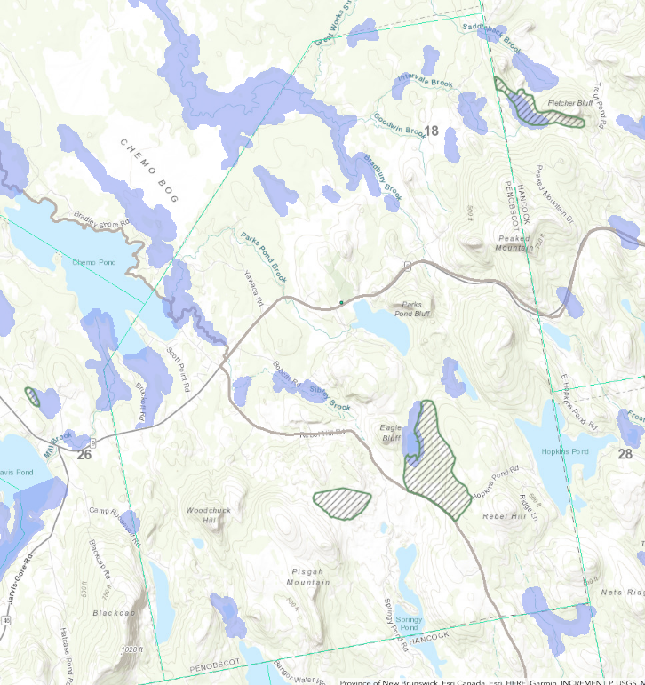
ENDANGERED AND THREATENED SPECIES
Peregrine Falcon
In the 1940s peregrine falcons nested in the Eagle Bluff area. People observed a male peregrine in 1994 staking out a nesting territory on Eagle Bluff and driving away ravens from the area, but no female peregrine came to join him and after three weeks he departed. Currently the MDIFW show peregrine nesting possibly just southwest of Clifton on a second hilltop called Eagle Bluff in Dedham.
Residents reported a pair of peregrine falcons in the vicinity of Peaked Mountain during 2001. Peregrine falcons are “endangered” in both Maine and the United States and are making a slow recovery after being reintroduced along the eastern seaboard in the last 10- 20 years.
Source: ESRI Imagery, Maine Department of Inland Fisheries and Wild Life; hashed are deer wintering areas; purple shading are wading bird habitats

Tidewater Mucket
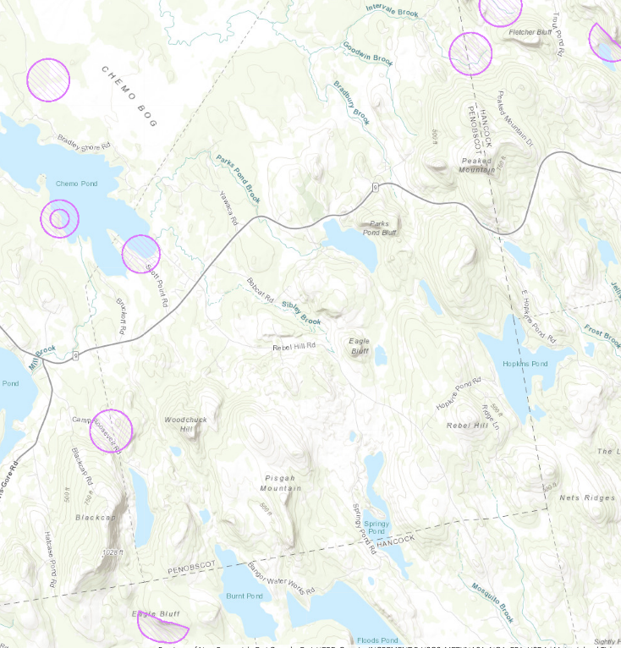
In 1995 biologists observed the tidewater mucket, a freshwater mussel, in Chemo Pond. The tidewater mucket is listed as “threatened” in Maine because its range-wide population trend is marked by widespread declines; its range in Maine is restricted to 3 mid-coast drainages, and its distribution within these drainages is limited to 9 discrete, non-contiguous areas; the major proportion of its population is in only five of those areas. Found in very low numbers at nearly all locations where it occurs and its fragmented population distribution, its common to find it between drainages. In fact, many of America’s freshwater mussels are threatened and endangered species because of similar circumstances. Elsewhere, the tidewater mucket appears on the endangered list (Connecticut) and of special concern in Massachusetts; other states within its range (which extends along the eastern seaboard as far as Georgia) are considering listing it as well.
Blue Heron
Bald Eagle
Peregrine Falcon
Tidewater Mucket
Great Blue Heron
Over the course of the last decade the Maine embarked on a study of the Great Blue Heron – the great blue is the largest heron in North America, standing more than 4 feet tall with a 6-foot wingspan and distinctive yellow bill, is migratory and lives a somewhat reclusive life. It has a lifespan of about 15 years. They nest in the same colony, or rookery, each year. Generally these colonies have dozens of nests bunched together in areas with sparse human populations. The birds nest together for protection from predators like eagles, foxes, hawks and raccoons. Great blue herons are common in Maine, however a decline in the coastal nesting population since 1980 caused concern among state biologists. MDIFW recruited volunteers to help check colonies, which are often far from trails or roads. In 2017, state employees and volunteers surveyed 60 active colonies with 629 nesting pairs. The state estimates there are as many as 1,500 nesting pairs statewide. Colonies may survive 40 to 60 years.
Bald Eagle Nest Sites
Historically, Maine was home to hundreds of pairs of bald eagles nesting along undisturbed shorelines of the coast, lakes, and major rivers. However, largely due to DDT contamination, eagle populations declined so drastically the federal government placed them on the Endangered Species list in 1978. As DDT residues in the environment dropped, bald eagles began to recover in Maine. Increasing losses of undisturbed nesting sites during the late 1980s, however, threatened further population growth and recovery of the species. Adequate numbers of young eagles must be produced from Maine's traditional eagle nesting sites if the population is to achieve a lasting recovery from Endangered or Threatened status. Loss of undisturbed nesting sites is now the greatest danger to Maine's eagle population. For this reason, designation of nest sites as essential habitat plays an important role in the recovery of Maine's bald eagle population. The microburst the end of October 2017 resulted in taking down the large White Pine in Eddington on Chemo Pond with a nesting eagle family. People are watching closely to see if or where the family will re-locate locally.
OTHER WILDLIFE
Other wildlife habitats of note in Clifton include large, undeveloped habitat blocks, riparian habitats, and vernal pools. Undeveloped blocks of forest and wetlands provide habitat for wide ranging mammals such as those listed below. Vernal pools are significant wetland resources that are not often protected under general wetland regulations due to their small size. Riparian areas offer habitat for many plants and animals and can also serve as wildlife travel corridors, as well as playing an important role in protecting water quality.
The Town of Clifton, because of its landscape and rural nature, is home to many other types of wildlife. Some more interesting wildlife observed includes: loons, songbirds, hawks, owls, bear, moose, bobcat, wild turkey, and coyote.
ANALYSIS
Trends
> Wildlife
Regarding data and information, the best place to look is at the agency responsible for managing the resource: Maine Department of Fisheries and Wildlife. Despite sometimes-cantankerous politics in Augusta, the MDIFW seems to be pretty consistent in managing these resources. The MDIFW collaborated with over 100 state and federal agencies tribes, non-profit organizations, species and habitat experts, and other conservation partners to create Maine’s 2015 Wildlife Action Plan (the “Plan”). The Plan identifies 378 at-risk species (“Species of Greatest Conservation Need” or “SGCN”) that need our attention in the next 10 years to prevent further population declines. Maine’s Plan addresses the full array of wildlife and their habitats in Maine -- vertebrates and invertebrates in terrestrial and aquatic (freshwater, estuarine, and marine) habitats. It builds on a long history of public involvement and collaboration among conservation partners.
Based on local conversations and observations, Clifton tends to follow state trends in terms of hunting activity. Overall, during the past ten years resident hunting licenses are up about 15% while non-resident licenses are off 10%. In general, migratory fowl hunting is down by two-thirds over the past decade. Meanwhile turkey hunting is up about 20 percent. Deer hunting, one of the most popular sports continues to enjoy its status with harvests increasing in recent years.
The Clifton portion runs around 16 to 18 deer per year with a recent high of 23 in 2013 and low of 13 in 2011.
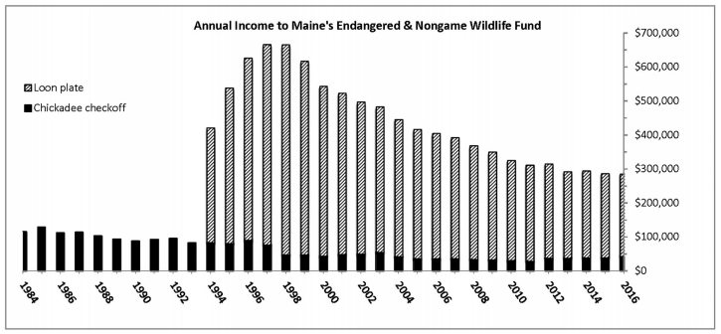
In terms of conservation interest at state level, typical channels are down mostly due to increased competition for donation dollars. Bothe the tax form Chickadee check off and the Loon plate purchase have many competitors. The chart below shows the overall declining revenue at the state level for such conservation programs apart from hunting and fishing.
That said, the local public opinion survey (see chapter) indicates strong local interest in conservation, maintaining working forests, visual aesthetics, outdoor recreation and similar vocational and recreational interests.
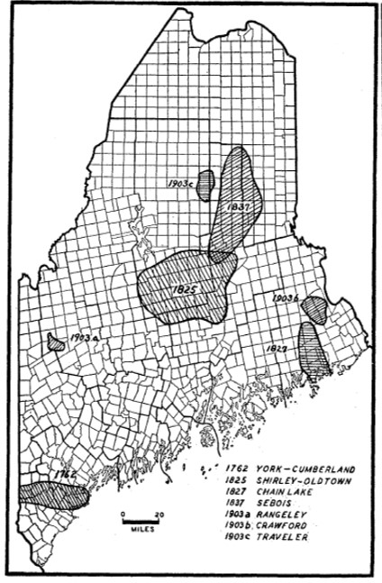
> Forest Fires
In recent years, major fires roared out of control in Canada and the United States. Maine and Clifton are not immune from such calamity and there is historic precedence. The year was 1947 and fire leveled nine Maine towns - many others suffered severe damage and 16 people died. Property losses were set at a 1947 figure of $30 million – or over $300 million today. This does not take into effect the increased population and increased size and complexity of modern structures and related infrastructure. A comparison analysis prepared by the state of Maine based on 1996 property values pegged the loss to over $2.4 billion or closing on $4 billion using the past 20 years of inflation.
As large and destructive as these fires were, the largest forest fire was the so-called Miramichi Fire of Oct. 7, 1825, which burned an amazing 832,000 acres of Maine forest and 3 million in New Brunswick. This is according to the Maine Forest Commissioner's Report of 1947.
Source: Acadiensis, Charles Fobes map of historic forest fires in Maine, 1947.
Protective Measures
There are no current protective, responses or other organized contingency plans in place to cope with a significant forest fire. This is an opportunity for the town.
The CLUO contains extensive protective measures to ensure management and preservation of natural resources. Several large and unique tracts currently enjoy perpetual protection. See the map below

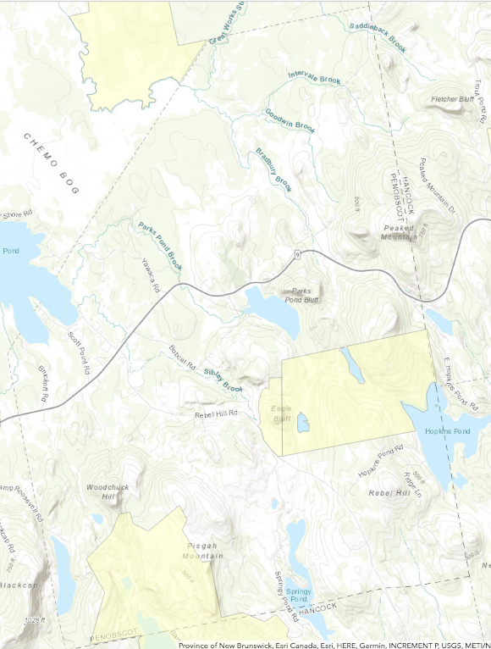
Shipley Parcel –
Forest Society of Maine
Eagle Bluff
Bangor Water District
International Paper

Local Forest, Agriculture and Other Natural Resource Sustainment
The public survey indicates keen interest in natural resources. The Planning Board should keep this in mind when they consider development options or proposals town wide as well as future reviews and revisions in the CLUO.
Clifton is no different than other areas with regard to being subject to natural calamities as well as from time to time, the mischief of humans. Local government should consider contingency plans for water bodies and resources most importantly when there will be a substantive economic impact from the loss of use.
Because Clifton has a heavy forest cover type, it is also possible significant forest fire could entirely destroy the entire town or at least specific communities such as Scott Point where there are many tall pines and well developed year around houses. Aside from the obvious human loss, houses, memories, and emotional trauma of fire, there could be sustained reduced tax revenue for several years not to mention planning procedures and actions about re-building.
POLICY AND IMPLEMENTATION PLAN
Unlike water resources, the agricultural and forest resources are largely private property. While the property is private, the game living on the property (not the varmints and nuisances) belongs to the State and thus there is a government interest in some aspects of property management. As discussed in the Water Resources, the CLUO provides substantial protection for forest, agricultural, and natural resources including dividing the town into logical zoning districts with zone specific standards.
There are additional measures the town may consider to protect people, private, and public assets as well as the financial well being of the community.
The major agricultural resources in the town are blueberry barrens. The town may wish to work with the landowners to discuss what, if any incentives are available to sustain these resources as barrens.
Key to overall development and financial security are good community relations. The town should consider available options fostering mutual appreciation where forest and agricultural activities border residential areas.
The unique natural resources in Clifton present a prime opportunity for destination adventure activities. These activities could provide jobs and spawn additional support business interest. If the town pursues economic development functions, this should be near the top of the list after evaluating the industrial zone.
Timber harvesting in residential areas is a bit different than more rural areas. The town may wish to consider workday ordinances in residential areas to maintain the peace for timber harvesting activities not riven by an emergent condition such as fire, storm, or other disaster.
Due to public interest, the town may consider mailings or surveys encouraging interested parties to form a non-binding advisory group to participate in inter-local and/or regional planning, management, and/or regulatory efforts around shared critical and important natural resources and also to pursue public/private partnerships to protect critical and important natural resources through purchase of land or easements from willing sellers.

CRITICAL
The town needs to prepare for hazards and emergencies based on its rural setting, historical problems with storms, growing residential density in heavily forested areas (in particular Scott Point) and its aging population.
As previously discussed, forest fires can move quickly and be deadly in the immediacy of the event and have years of post event consequences. The time to consider and model the impacts of such a catastrophe is before the event occurs – not after. The town should develop a risk based approach starting with areas more thickly settled with limited escape avenues. The town should also assess its tinder risk based on harvesting practices, weather patterns, or other factors as people begin to consider this type of event.
The town should consider contracting with a forester to review the big picture of timber in town and to recommend where the highest hazard of starting a fire exist and work with regional responders to determine focus areas and management protocols should the fire occur. The town should consider evacuations notifications, procedures, sheltering, feeding, and release options.
Working with Maine Emergency Management Agency, the County Emergency Management Office and community volunteers and also possibly contracting with an emergency management professional to provide oversight. It may be a worthwhile investment. Clearly, any efforts in this regard would have to include coordination with neighboring communities.

FOREST, AGRICULTURAL, and OTHER NATURAL RESOURCES FINANCIAL RESOURCES
Below is an abbreviated listing of resource funding and assistance programs and descriptions of those programs.
Beginning With Habitat Program
The Beginning with Habitat Program (BwH) provides objective and comprehensive habitat information to equip decision-makers with the necessary tools to make informed and responsible decisions. The Program can provide educational presentations, technical assistance on municipal land use planning, as well as the most current plant, animal, and natural community data maintained by MNAP and IF&W. BwH also provides maps and information on riparian areas, undeveloped blocks of land, conservation areas, wetlands, characterization and focus areas of statewide ecological significance. The Town may contact the Program Coordinator for assistance.
Soil and Water Conservation District
Maine’s 16 Soil and Water Conservation Districts (SWCD) are subdivisions of state government that are run by locally elected and appointed volunteers. Generally their jurisdiction follows county boundaries. The SWCD purpose is to solve local natural resource conservation problems (both urban and agricultural) as determined by local stakeholders. Not only do districts work with their partners to identify natural resource problems at the local level and develop solutions, they also assist in getting those measures applied to the land. This is accomplished by a unique partnership with the United States Department of Agriculture, Natural Resources Conservation Service (NRCS) and the Maine Department of Agriculture, Food and Rural Resources (MDOAFRR). NRCS provides technical support of district programs and MDOAFRR is the state agency that provides administrative oversight of district programs and administers basic state funding grants to districts. The Penobscot County SWCD is located in Bangor.
Natural Resources Conservation Service
The Natural Resources Conservation Service (NRCS) is an agency of the U.S. Department of Agriculture. NRCS offers help to individuals, groups, towns and other units of government to protect, develop and wisely use soil, water and other natural resources. NRCS is to provide leadership and administer programs to help people conserve, improve and sustain our resources and environment. The mission of the Natural Resources Conservation Service in Maine is to “provide technical assistance to help people conserve, improve and sustain our natural resources.”
Farm Security And Rural Investment Act Of 2002 (2002 Farm Bill)
The Farm Security and Rural Investment Act of 2002, signed into law by President Bush on May 13, 2002, is landmark legislation for conservation funding and for focusing on environmental issues. This legislation simplifies existing programs and creates new programs to address high priority environmental and production goals. The 2002 Farm Bill enhances the long-term quality of the environment and conservation of natural resources.
Some of the programs that the Natural Resources Conservation Service (NRCS) administers which were authorized or re-authorized in the 2002 Farm Bill include:
Farmland Protection Program
The Farmland Protection Program is a voluntary program that helps farmers and ranchers keep their land in agriculture. The program provides matching funds to State, Tribal, or local governments and nongovernmental organizations with existing farmland protection programs to purchase conservation easements or other interests in land.
National Natural Resources Conservation Foundation
The National Natural Resources Conservation Foundation (NNRCF) promotes innovative solutions to natural resource problems and conducts research and educational activities to support conservation on private land. The NNRCF is a private, nonprofit 501(c)(3) corporation. The foundation builds partnerships among agencies and agricultural, public, and private constituencies interested in promoting voluntary conservation on private lands.
Resource Conservation and Development Program
The Resource Conservation and Development Program (RC&D) encourages and improves the capability of civic leaders in designated RC&D areas to plan and carry out projects for resource conservation and community development. Program objectives focus on “quality of life” improvements achieved through natural resources conservation and community development. Such activities lead to sustainable communities, prudent land use, and the sound management and conservation of natural resources.
Wetlands Reserve Program
The Wetlands Reserve Program is a voluntary program that provides technical and financial assistance to eligible landowners to address wetland, wildlife habitat, soil, water, and related natural resource concerns on private land in an environmentally beneficial and cost-effective manner. The program provides an opportunity for landowners to receive financial incentives to enhance wetlands in exchange for retiring marginal land from agriculture.
Wildlife Habitat Incentives Program
The Wildlife Habitat Incentives Program (WHIP) is a voluntary program that encourages creation of high quality wildlife habitats that support wildlife populations of National, State, Tribal, and local significance. Through WHIP, NRCS provides technical and financial assistance to landowners and others to develop upland, wetland, riparian, and aquatic habitat areas on their property.

