STATE GOAL
Lacking any current guidance or vision at the state level, the two major thrusts for the next five years from the Maine Chamber of Commerce are:
Goal 1: The Maine State Chamber of Commerce will help Maine reach and sustain 2-3% Real Gross Domestic Product (GDP) growth throughout the forecast by continuously improving the underlying processes that drive business investment throughout the State.
Goal 2: The Maine State Chamber of Commerce will enhance the quality of life for all Mainers by supporting processes that balance financial, social, and environmental needs of our communities.
LOCAL GOAL
Clifton strives to assist vulnerable citizens accessing programs necessary for basic living and to support protecting investments in housing and property management; leveraging resource and recreational asset development opportunities; and developing the Clifton industrial zone.
INTRODUCTION
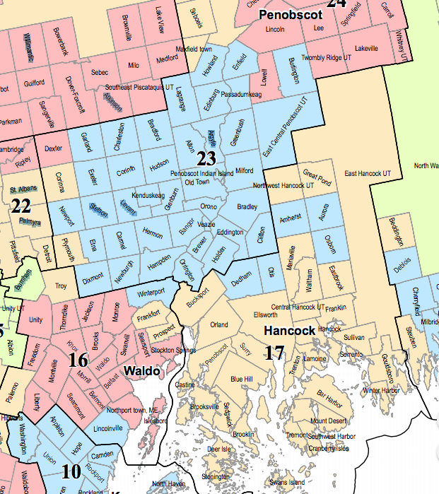
Clearly Clifton is not a major economic center or even a major supplier of raw material or human resources to any regional centers. Clifton is predominantly a bedroom community with some great natural resources assets supporting a comfortable life balance to working people. With this fact in mind, Clifton has several small businesses and an industrial zone with the potential to develop providing jobs to residents and people in adjoining towns. In particular, the former Leon Williams Limber Mill site on the Clifton town line with Eddington is the industrial zone.
In 2000, Clifton was a part of the Ellsworth Labor Market Area; in 2010, this changed. Clifton is now part of the Bangor New England City and Town Area (NECTA). The map shows Clifton (red shading) and the surrounding region.
EMPLOYMENT, INCOME, HOUSEHOLD FINANCE OVERVIEW
Statewide (data sourced from the Maine Department of Labor), workforce growth only increased by about a half a percent per year over the past 25 years to about 705,000 (round numbers) from about 630,000 people in 1990. Clifton followed the same growth path from about 340 to 380 except, Clifton arrived at 380 in 2000 and since then, the number is still about 385 working people in 2018. These are not jobs in Clifton – this is the estimated number of employed people.

There are not enough people or adequate data to accurately discuss the types of occupations people have in Clifton except to indicate nearly all working people are in the service sector with nearly no representation in manufacturing which is consistent with the region. The reason for not producing tables as in the past is because the current breakdown on the US Census website shows 50% margins of error for most occupations.
Over the past ten years (which included a significant recession), Maine unemployment was about a percent less than US unemployment (in other words, it was better in Maine than the US average). Over the same period, the Bangor Metropolitan Service Area (MSA) had slightly better working conditions than the state or Penobscot County. Clifton, lying on the edge of Hancock County, is more likely affected by factors from both regions and Hancock County unemployment is notable as significantly worse than Penobscot County during the most difficult periods. See the graph below; the graphs show annual averages. Breaking it down by the month would demonstrate many peaks and troughs particularly in Hancock County where the seasonal economy is more predominant.
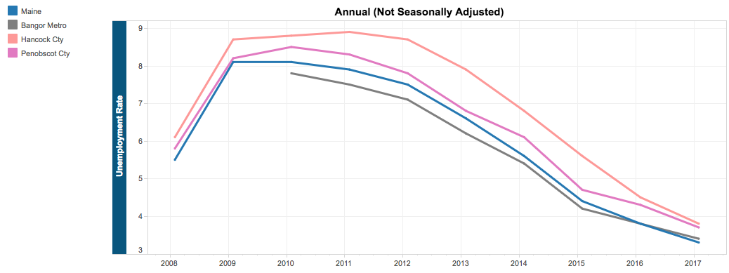

In the region, Clifton has some of the lowest financial wealth per household in the immediate area however, the median is slightly hire than the entire Bangor MSA. Note the chart below shows both median and mean. Mean is the average of everyone meaning a few very large incomes will skew the average up in a small community and median is the midpoint. Median is the point where half of the homes estimated are below the level and half are above the level. Added to the graph are figures for the Bangor MSA.

As the demographic portion of the plan indicates, the Clifton population continues to age. The next couple charts illustrate households receiving social security and/or retirement income. Social Security income numbers include disability and retirement income. Clifton residents are behind other towns in the area when it comes to retirement income collection relative to social security recipients – in other words, households in this bracket rely solely on social security benefits and not a combination as appears to the be the case in surrounding communities. This might suggest the people here pre-dated the era of various plans or did not work at the types of jobs enabling saving towards retirement as well as surrounding towns.
The income graph shows the average social security and retirement incomes from the sub-group of households on the previous chart who are receiving these benefits. As expected, the average social security income per eligible household is consistent for the towns versus retirement income, which would vary based upon what people did, for whom they worked, and were able to save throughout their lives.
The following two charts show more generalized economic indicators illustrating income groupings by household and number of families on food stamp benefits or supplemental nutrition assistance program (SNAP).

SNAP is the program formerly known as food stamps; it is a federal nutrition program that helps stretch a food budget and buy healthy food. SNAP benefits are for food purchases at grocery stores, convenience stores, and some farmers' markets and co-op food programs. SNAP is a federal entitlement program administered through the USDA and does not impact local welfare entitlements. What this chart does help to understand is the level of regional need and combined with other relevant statistics in this report will help inform people creating policies and fee structures to understand the potential impact on vulnerable populations.
Two more economic indicators for the community are health insurance and percentage of families below the poverty level at any time during the previous 12 months. Following are graphics comparing Clifton, neighboring towns, and the Bangor MSA. Clifton is a leader in public coverage for its citizens and is in the middle of the pack for citizens with no coverage. Eddington does well with both healthcare and keeping people above the poverty levels having both the fewest uninsured and with the lowest percent of its population below the poverty level.

These metrics (SNAP, income, poverty, healthcare) are pretty consistent across the board for needs indicating there are between fifty and sixty families or households having a sustained need in Clifton. These families may need a little extra help if they are trying to come up out of a tough situation; these are people who would be unable to effectively contribute to local financial prosperity yet may be able to contribute in other ways to community health.

REGIONAL INFORMATION – MACRO VIEW
The wider context of retail sales shows fairly solid growth from 2011 through 2016 (latest available data) with a sharp upswing between 2015 and 2016. Bangor grew from nearly $1.6 billion in 2011 to nearly $1.8 billion in 2016 at an annual rate of 2.5% versus Bangor suburbs growing at a rate of 3.5%. Eastern Maine grew at an incredible rate during the same period seeing 38% total growth in Bar Harbor with 10.7% between 2015 and 2016 alone. Ellsworth grew a strong 7.1% between 2015 and 2016 showing its gravitational force.
When looking at growth areas or areas decreasing in sales, looking at taxable sales is useful to help gauge the bigger picture. Following is a table showing annualized taxable sales growth (average annual growth) from the period 2011 through 2016.
 | Total Retail | Consumer | Auto | Building | Food | General | Restaurant | Lodging | Other
BAR HARBOR | 6.69% | 7.19% | 6.22% | 6.03% | 9.08% | -0.54% | 7.54% | 9.11% | 2.99%
BLUE HILL | 2.99% | 3.68% | -4.63% | 4.28% | 6.76% | -5.59% | 5.88% | 4.00% | 2.84%
CALAIS | 2.40% | 2.97% | 6.91% | -2.04% | 3.96% | 3.14% | -0.08% | 3.40% | 3.79%
EASTPORT | 1.80% | 2.36% | -2.14% | -3.09% | 3.39% | 13.89% | -2.36% | 3.71% | 2.07%
ELLSWORTH | 4.10% | 4.47% | 6.65% | 1.86% | 6.45% | 4.66% | 1.52% | 7.34% | 2.11%
JONESPORT | 4.10% | 4.81% | -0.09% | 5.72% | 7.53% | 5.87% | -2.48% | 1.87% | 9.43%
MACHIAS | 2.22% | 2.14% | -4.94% | 3.44% | 7.52% | -1.54% | -0.34% | 6.99% | -0.02%
EASTERN ME Total | 4.39% | 4.86% | 5.16% | 2.82% | 6.72% | 3.94% | 4.32% | 8.30% | 2.72%
BANGOR | 2.49% | 2.74% | 4.54% | 3.17% | 4.38% | 0.26% | 3.31% | 4.28% | 1.63%
BANGOR SUB | 3.49% | 4.85% | 5.66% | 4.57% | 5.46% | 6.19% | 1.19% | -2.12% | 4.83%
DOVER-FOXCROFT | 3.78% | 4.00% | 1.55% | 4.32% | 6.71% | 3.67% | 6.33% | 5.30% | 0.07%
LINCOLN | 4.75% | 3.62% | 3.53% | 6.45% | 4.69% | 2.16% | 2.26% | -6.41% | 7.24%
MILLINOCKET | 1.71% | 2.27% | -0.78% | 1.16% | 3.63% | 4.03% | 1.85% | 6.18% | 3.10%
WINTERPORT | 4.32% | 5.63% | 8.94% | 2.89% | 4.17% | 11.40% | 2.54% | 10.81% | 0.47%
PENOBSCOT Total | 2.84% | 3.20% | 4.56% | 3.62% | 4.93% | 0.70% | 3.14% | 4.05% | 2.04%

GEOGRAPHY
Location | Distance (mi) | Travel Time (hh:mm)
Brewer (Shopping, jobs, Lafayette Cancer Center) | 14 | 00:22
City of Bangor (Shopping, jobs, surgical hospitals) | 15 | 00:24
Bangor International Airport | 17 | 00:31
University of Maine (Orono) | 23 | 00:37
Ellsworth (Shopping, jobs, Downeast Gateway) | 25 | 00:33
Belfast, ME (working waterfront) | 41 | 00:58
Bar Harbor (Acadia National Park) | 46 | 01:06
Dover-Foxcroft, ME (Piscataquis County Seat) | 51 | 01:13
Calais (US Border - east) | 84 | 02:06
Greenville (Moosehead Lake) | 84 | 01:58
Augusta, ME (State Capital) | 91 | 01:27
Baxter State Park | 118 | 02:56
Sugarloaf USA (Ski Resort) | 118 | 02:20
Houlton (End I-95N) | 126 | 01:59
Portland, ME (Largest City in State) | 145 | 02:14
Colburn Gore (US Border - west) | 150 | 03:33
Sunday River (Ski Resort) | 158 | 02:51
Fredericton, NB | 162 | 03:28
Portsmouth, NH (Maine Border – south) | 196 | 03:00
St. Leonard, NB (US Border - north) | 225 | 03:48
Quebec City, QC | 245 | 05:04
Logan International Airport/Boston, MA | 250 | 03:49
New York City, NY | 454 | 06:58
Washington, DC | 684 | 10:21
Walt Disney World (Orlando), FL | 1340 | 22:42
Key West, FL | 1582 | 28:00:00
Clifton’s location on Route 9 is just far enough out of the Bangor-Brewer area to not provide spillover business opportunities such as those possibly available in Eddington (though there are few businesses in Eddington of any magnitude) or more obviously in Hampden (Routes 1A and 202), Orrington (Route 15), Holden (Route 1A), or Veazie nestled between Bangor and Orono. In terms of future development, Clifton does have the potential to grow after the I-395 Connector is complete. The reason for this would be reduced travel time from Bangor to Clifton by five to ten minutes. This connector saw many planning iterations over the past fifteen years including connecting directly to Route 9 at the Clifton-Eddington town line at the time of the last publishing of the Comprehensive Plan. Currently the plan has the road intersecting Route 9 about 3 miles from the westerly boundary.
The driving distance and location table shows the distance and rough travel times from Clifton to various logical business opportunities and recreational destinations of interest.
ZONING
Clifton’s Industrial Zone, located on its westerly boundary with Eddington and south of Route 9 is part of Growth Management Area (GMA) 1B (Enterprise) and is adjacent to GMA 1A (Village). See the map. Article 3 of the Clifton Land Use Ordinance (CLUO) establishes GMA 1A and 1B for the following purposes:
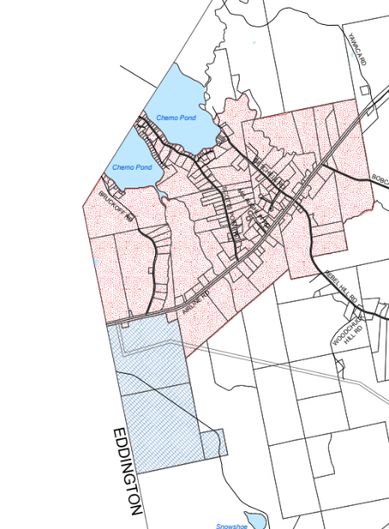
GMA 1A (dots) - This overlay area, as so designated on the official Growth Management Area Map of Clifton, Maine, relates to the ‘moderate density district’ envisioned in the Comprehensive Plan [2005]. Its primary intent is to encourage a compact village of single and multifamily homes, mobile home parks, offices, schools, public facilities and small businesses and municipal offices. This area is the traditional core of the community with the historically oldest settlement and the most diverse existing development pattern.
GMA 1B (hashed) - This overlay area, as so designated on the official Growth Management Area Map of Clifton, Maine, relates to the ‘industrial/commercial growth district’ in the Comprehensive Plan [2005]. Its primary intent is to provide a compact enterprise area near utilities for industrial operations and commercial applications. As the site of a lumber mill, this area has an established industrial/commercial use designation and is well situated to receive additional commercial or industrial development.
If there is ever to be significant economic growth in Clifton (in terms of jobs), GMA 1B is the target area for this type of development opportunity. Should the town ever contemplate working with a consultant or have a position targeting economic development, this should be a focal point for the person or firm.
POLICIES and PROCEDURES
In general healthy employed people take care of themselves. A basic function of government is citizen welfare and while Clifton is not the direct provider of financial, food, healthcare, and non-emergent shelter resources (most of those resources come from the state or federal government), Clifton can take an active role following through and advocating for people lacking resources. To this end, Clifton may consider ensuring aid agencies are providing services and also, provide meeting space for aid agencies on a regular basis throughout the year. Clifton may also consider helping to market services provided by local non-governmental organizations (NGO’s) to ensure the most vulnerable people are at lease aware of services.
The Clifton Boards and Code Enforcement Officer should continue to work together to enforce the existing land use ordinances and also to clarify portions (using the updating processes outlined in the ordinance and with detailed interpretive letters or reports when needed) of the ordinance not well understood. This is particularly common for shore land zoning issues. With the advent of Air BnB and other rental or property management activities, the ability to have good commerce depends upon maintaining quality waterfront communities. Additionally, as people age, they decide to move closer to medical facilities or into apartments or other shared living arrangements. The ability of people to get the best value from property depends upon marketing the property as well as the neighborhood.
Clifton promotes agricultural business. Some seasonal agricultural production and processing uses have the look and feel of industrial or commercial uses. Clifton is very liberal in its approval process for agricultural production and sales compared to neighboring communities; this liberal pro-small scale agricultural business approach will only be sustainable if applicants and code enforcement follow through. This will bring great financial benefit to citizens and the town in the long run as opposed to having an aggressive rule set dissuading agricultural business.
The Town should work with the landowners of the enterprise zone to encourage development. This area is historically industrial and at one time, provided employment for close to one hundred people. If the site generated $4 million of payroll income, the net regional economic impact would be about $12 million per year.
Clifton should work with the lakeshore landowners – in particular Chemo Pond and secondarily Parks Pond to get better public access. Public access will improve opportunities for people to develop recreational businesses and also for non-waterfront land owners to access water – a public good. Providing public recreational access to water activities improves the overall livability and vibrancy of the community.
Clifton has some of the best easy hiking and vertical climbing relief in Eastern Maine. Many unexplored recreational business opportunities exist for day hiking, destination multi-day recreational activities, and possibly even fine dining and food services. The zoning ordinance supports these activities fairly well. Should the town pursue economic development functionality, these are the types of activities worth investigating.

