“There is a strong link between the special character of Maine's places and its economic, environmental, and community values. This report recognizes that “quality of place" is a driver for our recreation economy and a source of health and well-being.”
Maine SCORP Planning Team (2014)
STATE GOAL
The Maine Bureau of Parks and Lands (BPL) has an on-going strategic planning process renewing their plan every five years. The current plan is the Maine State Comprehensive Outdoor Recreation Plan 2014-2019. The plan lists three priority areas.
Priority Area 1: Connect More Mainers of All Ages with the Health and Wellness Benefits of Outdoor Recreation.
Priority Area 2: Support Regionally Connected Trail Systems in Maine’s Less Developed Regions to Increase Access to Outdoor Recreation for Maine’s Rural Population and Enhance Economic Development.
Priority Area 3: Connect to Future Tourism Markets through Recreation Interests.
LOCAL GOAL
Clifton will develop and market its outdoor recreational assets to residents and people throughout to region to become a popular day trip destination location enhancing local economic development and being an integral part of regional health and wellness.
RECREATION
rec·re·a·tion
/ˌrekrēˈāSH(ə)n/
noun
activity done for enjoyment when one is not working.
Recreation can take place either indoors or outdoors. Outdoor recreation relates to open space and consequently to undeveloped land. Open spaces include agricultural and forest lands, wetlands, mountains, lakeshores, and river corridors. While not all open space is accessible to the public, areas such as parks, ball fields, snowmobile trails, and areas for hunting are all types used for recreation. Many Mainers believe because the state is largely rural, there will always be plenty of open space. As regional population increases, request for recreational areas and opportunities on undeveloped land will also increase. Much of Clifton’s land is privately owned and people using this land should be respectful to ensure landowners will not revoke this benefit.
Reviewing the state recreational priorities, a short primer may help understand the rationale for the priorities and help guide decision making for the future. Directly from the Statewide Comprehensive Outdoor Recreation Plan (SCORP): “the federal Land and Water Conservation Fund program (LWCF) provides matching funds to states for statewide outdoor recreation planning and for acquisition and development of public outdoor recreation areas and facilities. From 1966 through 2013, just under $40 million of LWCF money has been used for non-federal projects in Maine. Administered at the federal level by the National Park Service and at the state level by the Bureau of Parks and Lands (BPL) in the Maine Department of Agriculture, Conservation, and Forestry, LWCF grants can provide up to 50% of the allowable costs for approved acquisition or development projects. Municipalities, schools, the State of Maine, and tribal governments are eligible to apply for local LWCF grants through BPL.”
The [1965] LWCF Act requires an approved SCORP to include the following requirements of Chapter 630.1 of the National Park Service LWCF guidelines:
- Evaluation of the demand for and supply of outdoor recreation resources and facilities in the state
- A program for implementation of the plan
- Certification by the Governor that ample opportunity for public participation has taken place in plan development
Prior to 2001, Maine state law required BP&L to periodically report to the governor on the supply of and demand for outdoor recreation facilities and how these might be met (12 MRSA 1817). Submittal of the SCORP to the Governor accomplished this reporting requirement. In 2001, the Maine Legislature amended this law to require the BP&L director to submit a state comprehensive outdoor recreation plan to the joint standing committee of the Legislature having jurisdiction over state parks and public lands matters every 5 years. The amendment specifies that a plan meeting the federal SCORP requirements will also satisfy legislative requirements, further formalizing the role of SCORP in state government.
The current plan is available here: https://www.maine.gov/dacf/parks/publications_maps/docs/final_SCORP_rev_10_15_plan_only.pdf. People responsible for the upkeep of this section should continuously look for the most current version of the state plan since it is part of Maine law.
NATURAL FEATURES OVERVIEW
Residents of Clifton live in Clifton by choice to enjoy the beauty of the “enchanted environment” and an accompanying lifestyle. Clifton’s Land Use Ordinance promotes the use and protection of these resources. Survey results spanning back over three decades indicate residents of Clifton identify outdoor recreational facilities as a priority. Clifton residents also have a strong desire to protect the rural lifestyle and all the natural resources and beauty that make the Town so “enchanting.”
The rolling relief and sometimes-dramatic cliffs, with elevations between 140 and 1,152 feet above sea level, limits fixed asset economic development throughout most of the town. The topography and natural resources of the Town draw tourists to enjoy the essence of Clifton as a place. Below is a map showing an overview of accessible boat landings, climbing and hiking areas, and campgrounds. Despite several boat landings in use by town’s people and other visitors, there are no fully legal public landings. Virtually every cliff shown provides breath taking four season views; several cliffs are literally accessible within five to ten minutes walk from parking a car.
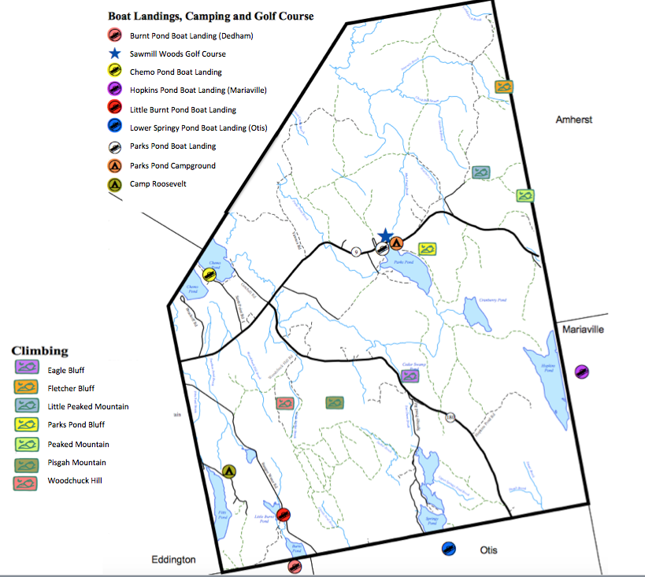
Source: Eastern Maine Development Corporation (2003)
CLIMBING/HIKING
The Town of Clifton has a wealth of natural recreational resources, starting with the cliffs for which it was named. Within the town boundaries are 10 sheer granite bluffs ranging from 40 feet to almost 400 feet. Rock climbers from all over eastern Maine -- including a large contingent from the University of Maine – a forty minute drive – come to Clifton to scale these cliffs, the most popular of which are Eagle Bluff, Parks Pond Bluff, Fletcher Bluff, and Peaked Mountain (often called Chick Hill, although the real Chick Hill is located one ridge to the north).
These peaks served as attractive destinations for generations of hikers and the number of rock climbers increased dramatically in 1991 after the National Park Service enforced a seasonal closing of the Precipice Trail at Acadia National Park to protect nesting peregrine falcons. This happened at approximately the same time that the University expanded its rock-climbing program and began using Eagle Bluff for student instruction and field trips.
An unexpected event threatened the privately owned Eagle Bluff parcel in 2013 and through a series of negotiations and efforts initiated by Planning Board (implementing a strategy recommended in the previous Comprehensive Plan) members and the Maine Coast Heritage Foundation and then actioned to fruition by a regional group who became the Clifton Climbers Alliance and national climbing advocacy group Access Fund, Eagle Bluff went into perpetual conservation in August of 2014. Demonstrating the regional importance of this site, it took a mere six months to raise $100,000 to bring this deal to closure. Many other groups also worked hard contributing money and in-kind support. For more details, see this website: https://www.accessfund.org/news-and-events/news/clifton-climbers-alliance-teams-with-access-fund-to-purchase-eagle-bluff
Multiple vehicles now occupy the trailheads on almost every fair-weather afternoon and weekend during the spring, summer, and fall. Some hardy souls even brave the winter elements to test their skills against the icy rock faces. While most hikers and rock-climbers are day-trippers, some bring backpacking equipment and camp on the summits or along the trail. Some even sleep in hammocks out over the ledges. All camping is primitive and only experienced people should camp in these areas for safety and sanitary reasons.
Popular hiking trails can also be found on Woodchuck Hill, Pisgah Mountain, and Little Peaked Mountain (a.k.a. Little Chick Hill). The highest point, Peaked Mountain, is located on the eastern border with Amherst. Most elevations above 700 feet are located along the Town’s southern and eastern borders.
Mountain | Elevation | Location
Woodchuck Hill | 834 | SW
Pisgah Mountain | 791 | S
Eagle Bluff | 700 | E
Parks Pond Bluff | 660 | E
Little Peaked Mountain | 900 | E
Peaked Mountain | 1152 | E

PUBLIC ACCESS TO WATER
Clifton also has numerous streams and ponds that provide motorized and non-motorized boating and open-water fishing from spring through fall, swimming in summer, and ice fishing during the winter. Parks Pond Campground rents out canoes, paddles, and life jackets to the general public, which may be taken offsite, or launched right from the campground beach. Years ago, there was a quasi-public swimming beach off the Scotts Point Road on Chemo Pond; however, when the property changed hands in the 1960s, public access came to a conclusion.
Eleven of Clifton’s ponds (Chemo, Hopkins, Burnt, Little Burnt, Snowshoe, Fitts, Parks, Cranberry, Cedar Swamp, Upper/Middle Springy, and Lower Springy) are Great Ponds (under Maine State Law classifying ponds covering over 10 acres). Seasonal and year-round camps and single-family homes occupy the shorelines of the larger ponds, primarily clustered around areas with road access.
As previously stated, there is no publicly owned access to any lake frontage in Clifton for swimming, fishing, boating or snowmobiling. There are a few locations in Town where the public makes use of privately owned land to cross to the water. Landowners vary in their receptiveness to this practice. Lack of parking facilities at these locations (and other recreational use locations in Town) creates problems with roads and driveways congested with parked trailers and vehicles hindering snow removal, limiting site distance and increasing safety hazards.
RECREATIONAL BOATING
Many residents and visitors to Clifton enjoy recreational boating. This may include motorized boating, canoe and/or kayaking, paddle boating, sailing, jet skiing, tubing, etc. Several small businesses developed over the past four to five years around boat rental and storage showing the potential for direct relationships between recreational activities and economic activities.
Clifton is reasonably lucky with boating safety; that said, there was a boating tragedy on Chemo Pond the summer of 2018 resulting in the drowning of one boater from a local community. Boating safety regulations are solely enforced by the Maine Department of Inland Fisheries and Wildlife (MDIF&W). Emergency response is via the MDIF&W or the Eddington Volunteer Fire Department.
FISHING
The most common fish taken from Clifton ponds are pickerel, white perch, smallmouth bass, lake trout (togue), and brook trout, while the streams produce wild splake. The State stocks Fitts Pond and Lower Springy Pond are stocked annually with spring yearling (9-11”) splake, and Hopkins Pond is stocked each year with fall fingerling (6-8”) brook trout. For more information about fish species in Clifton’s lakes and ponds, visit http://www.lakesofmaine.org.
Illegal introductions of new fish species present a continuing threat to native stock in Maine waters. Irresponsible “bucket biologists” who may bring exotic fish into the Town’s lakes and streams are a danger to this treasured resource. The Maine Department of Inland Fisheries and Wildlife highlights the following 5 key points:
1) it is illegal to stock any species of fish, even baitfish, in any Maine water;
2) penalties for illegal fish stocking can be very severe;
3) illegal fish stockings are equivalent to environmental pollution and ruin fishing opportunities for everyone;
4) illegal fish stockings are forever; and
5) illegally stocked fish can move into other waters, thus polluting an entire drainage.
Clifton may consider developing public education and outreach with the goal of preventing the introduction of exotic fish species. For more information on Maine fishing laws, visit: http://www.maine.gov/ifw/fishing-boating/fishing/laws-rules/index.html.
SNOWMOBILING, SKIING, SNOWSHOEING
Snowmobiles provide both recreation and transportation during winter months, traveling over logging roads, power lines, and trails on private land. No mileage on the international trail system (ITS) is located in Clifton, although an ITS Trail Connector passes through the northern part of town. Snowmobile clubs in the area include the Clifton Area Snowmobile Club in Clifton, the Eastern Maine Snowmobilers in East Holden and the Pine Tree Snowmobile Club in Milford. For more information on snowmobile laws and regulations in Maine, visit: http://www.maine.gov/ifw/atv-snowmobile/snowmobile/index.html. For more information on snowmobile clubs and trail maps, visit: http://mesnow.com/index.html. Below is a map showing the ITS as it crosses Clifton.
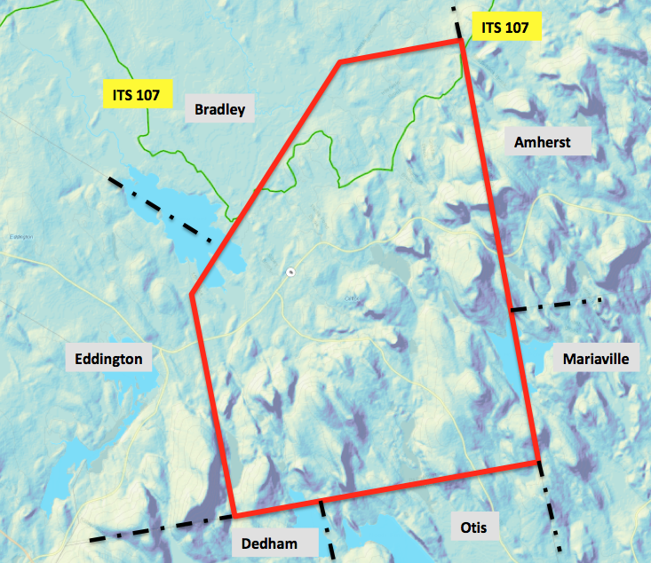
Source: Snowmobile Maine - http://www.mesnow.com/Map.html
Clifton Area Snowmobile Club
The Clifton Area Snowmobile Club established itself in February 2001 meeting the requirement for 15 members for club designation. The Club currently boasts 90 members and many accomplishments over the past 17 years. One of the proud accomplishments of the Club is the bridge built allowing snowmobile riders access to trails while staying off Chemo Pond. The Club maintains 30 miles of trails in the Clifton area. Below is a map showing the local snow mobile trails.
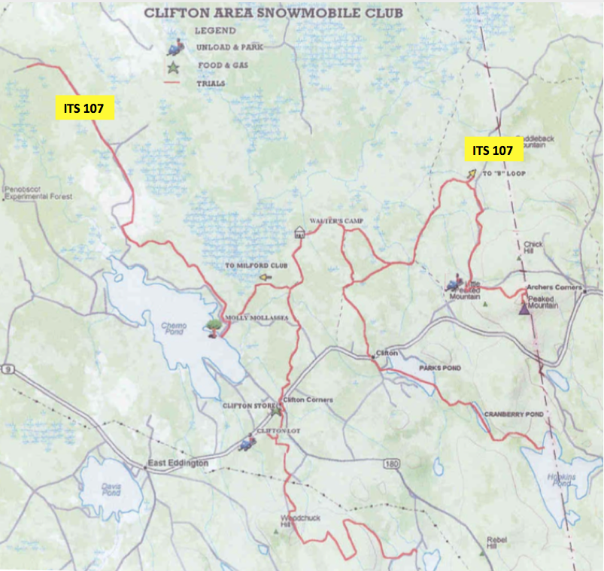
Source: Clifton Area Snowmobile Club
SKIING AND SNOWSHOEING TRAIL ACCESS
There are no trails specifically designated for cross-country skiing and snowshoeing; in general, the snowmobile trail users courteously share with these trekkers allowing many people to enjoy hills and lakes in the area. Trails to major bluffs such as Eagle Bluff, Parks Pond Bluff, and Peaked Mountain (aka Chick Hill) are accessible and maintained by users for winter hiking and snowshoeing.
ALL TERRAIN VEHICLES
Clifton is not part of any of the organized or recognized ATV trail networks in Maine. There are some trails in neighboring Amherst easily accessible to Clifton residents with ATV interests. For more information contact ATV Maine using their website: ATVMaine.org. As of 2019, the President of the local ATV group Airline ATV Riders is Jim Butler at 989-6545. There are regular monthly meetings in Eddington from January thru October.
HUNTING
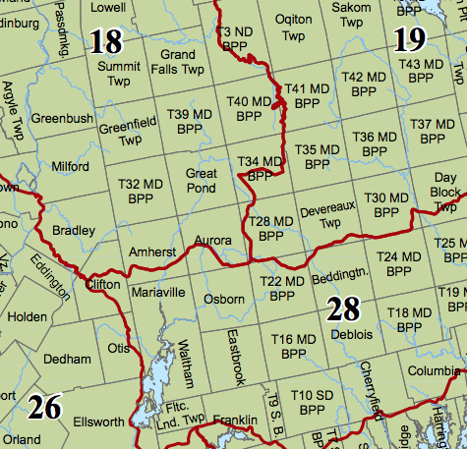
Clifton’s boundaries contain portions of Maine IF&W’s Wildlife Management Districts (WMD) 18, 26, and 28, and straddles the North-South Zone line for waterfowl (see the Natural Resources portion of the Comprehensive Plan for a more detailed analysis of deer population and resource management statistics). Hunters advantage Clifton’s many acres of quasi-public managed woodlands to pursue deer, moose, bear, snowshoe hare, fox, coyote, bobcat, raccoon, woodchuck, red and gray squirrel, skunk, porcupine, upland birds, crows, turkeys, and migratory waterfowl.
Source: Maine Department of Inland Fisheries and Wildlife
Trappers find an abundance of bear, coyote, fox, beaver, snowshoe hare, muskrat, fisher, skunk, raccoon, red squirrel, and weasel. Less commonly spotted are Mink and otter. Clifton United Baptist Church sponsors a Hunter’s Supper annually.
BICYCLING
Although many residents enjoy the activity, Clifton is not particularly hospitable for bicycling. Most of the town’s roads are narrow, without shoulders, and steep; approximately half are unpaved. Route 9 has wide paved shoulders - and fast-moving traffic with heavy trucking making for an unpleasant biking experience. Route 180 has very steep grades, blind curves, unpaved shoulders, and numerous gravel and logging trucks passing along a narrow roadway.
On the plus side, traffic volumes (other than on Route 9) are relatively low, permitting bicyclists to use the travel lane much of the time. The recent rise in popularity of off-road biking creates an economic opportunity for Clifton. Trails that take advantage of the region’s wooded terrain and dramatic topography could be developed, making Clifton attractive to mountain biking enthusiasts.
Despite the drawbacks, many children and some adults bicycle at least occasionally, either on-road or off-road on logging roads and ATV trails.
The same comments apply to walking and jogging for recreation aside from the trails, which do require a short drive for most and are not necessarily easy to walk for people without firm footing.
PARKS POND CAMPGROUND
Parks Pond Campground, located on Route 9, is open from mid-May to Columbus Day and offers both tent and camper sites and a rental cottage. The Campground provides tourists and residents alike many recreational opportunities. Parks Pond Campground rents out canoes, kayaks, and paddleboats, which can be launched right from the campground beach. For more information, visit: http://www.parkspondcampground.com.
SAWMILL WOODS GOLF COURSE
This nine-hole, par 36 public golf course is located across from Parks Pond Campground on Route 9. The course caters to golfers of all levels and abilities, and lessons are available. For more information, visit: https://www.sawmillwoodsgolf.com/.
CLIFTON PLAYGROUNDS
There are no public parks and/or playgrounds in the Town of Clifton. Currently, the closest playground is at the elementary school in Eddington. Residents expressed an interest in creating a town park/playground or recreation complex. Finding and funding a site is an issue.
CROSSROADS CHRISTIAN CAMP
The former YMCA Camp Molly Molasses, located on Chemo Pond and sold in 2013, now operates as Crossroads Christian Camp. Although the camp is in Bradley, the only access road passes through Clifton from Route 9. The facility offers summer day camps for children aged 6-13, running from June to late August. For more information, visit: http://www.crossroadscamp.org.
KATAHDIN SCOUT RESERVATION (CAMP ROOSEVELT)
The Katahdin Scout Reservation (KSR), owned by the Katahdin Area Council of the Boy Scouts of America, surrounds Fitts Pond; Camp Roosevelt is the built up living, dining, and activity complex on the site. Reservation is access is via Route 46 in Eddington and the majority of the land is within the Clifton boundary. KSR is available for Boy Scouts to use year round. During the summer Camp Roosevelt comes alive with scouts attending resident summer camp. Boy Scouts use the camp in July, and then in late July and August the Cub Scouts enjoy the facility. The year-round reservation serves for scout camping and training sessions as well as for camporees. The school district also uses the reservation in its fourth grade education curriculum. For more information, visit: http://www.katahdinareabsa.org/camping.
SCOUT TROOPS
There are at least two area options for Cub Scouts (aged 7-10) in the region; one troop that meets at the Eddington School (Pack #23) and one that meets at the Dedham School (Pack #21). For Boy Scouts (11-17 years old), Troop #23 meets at Comins Hall in Eddington, Troop #21 meets at the Holden Congregational Church, and Troop #01 meets at the First Congregational Church in Brewer. Girls in Clifton also have a variety of scouting options. Troop #720 is a Daisy Troop (kindergarten and first-grade) that meets at the Eddington School. Troop #728 also meets at the Eddington School, for Brownies (second- and third-graders). Cadette Troop #861 also meets at the Eddington School, for girls in sixth, seventh, and eighth grade.
EAST EDDINGTON GRANGE
East Eddington Grange (which includes Clifton residents in its membership) meets at Comins Hall in Eddington on the first Saturday of every month at 7 p.m. preceded by a potluck supper. The grange remains true to its agricultural roots and traditional community values, although most of its members do not earn their living by farming.
EDDINGTON CLIFTON CIVIC CENTER
The Eddington-Clifton Civic Center (ECCC) was formed in 1983 as a non-profit corporation whose purpose was to maintain and manage the East Eddington Public Hall. A local farmers group built the three-story hall in 1879. In 1983, the East Eddington Public Hall was renamed Comins Hall to thank the members of the Comins family for more than four generations of civic service to the Eddington Clifton area. In July 2003, Comins Hall was accepted for placement on the Maine and National Registers of Historic Places. Residents of Clifton and Eddington may become members of ECCC and support the preservation of this area landmark.
The ECCC ensures that historic Comins Hall is available to Clifton residents for public and private functions by advance reservation. For several years in the mid-1990s, prior to construction of the new town offices, Comins Hall served as the town meeting hall and voting site for Clifton residents. Sustainment is a challenge as it is expensive to keep up with life safety codes and handicap accessibility.
HOLBROOK REGIONAL RECREATION BOARD
There are no public facilities designated for organized recreational activities or sports within the Town of Clifton. Public recreational opportunities and facilities are through the school district for the communities of Clifton, Eddington, Holden, and Dedham. The Holbrook Regional Recreation Board is a four- member board, with one member from each town in the consortium, and has over 100 volunteers who donate countless hours coaching the teams, instructing youngsters, maintaining facilities and providing concession services.
Recreation opportunities offered to Clifton’s youngsters include Saturday soccer, pee wee basketball, and tee-ball, baseball and softball at the little league and farm league levels. In addition to programs for the youth, there is also a Tuesday night open gym for adults wishing to play pickup basketball. During winter months, adults also have organized basketball. The women play at the Eddington School and the men play at the Dedham School.
REGIONAL FACILITIES
In addition, to recreational facilities within Clifton, there are numerous facilities and activities in close proximity to the town, accessible to Clifton residents. Bangor/Brewer and Old Town/Orono offer a multitude of parks, pools, ice-skating rinks, two regional YMCAs, as well as a great variety of programs. The University of Maine offers trails for biking/in-line skating/running/walking and indoor activities. The Maine Audubon Society’s Fields Pond Nature Center located in Holden and Orrington offers a number of programs and activities and maintains nature trails throughout the year for nature enthusiasts. Finally, within a two-hour drive are several State and National Parks including world famous Baxter State Park featuring Mt. Katahdin and Acadia National Park, one of the nation’s most popular destinations in the Park system.
STRATEGIES and POLICIES
The value of recreation and open space within the community is a powerful incentive to draw people to Clifton. A golf course, boat launch facility, playground, tennis courts, biking trails, hiking trails, snowmobiling trails and nature observation are prime reasons to go to an area for a visit. Currently, the options are: day trips; private residence or camp rental; residency. Parks Pond Campground and the Sawmill Golf Course are the only two destination locations providing employment with guided activities. Clifton intends to use the natural resources of the town to create a recreation-based driving force for the town’s economy.
The definition of open space is broad and inclusive. The following examples qualify as open space:
● undeveloped land, lakes, rivers, oceans, mountains, wetlands, beaches, scenic vistas;
● developed land available for either active or passive uses; including highway rights-of- way, trails, landscaped areas, farms, forests;
● public land or public rights to land, including parks, recreation areas, schoolyards, coastal and other waterfront access; vacant lots owned by the town, state or federal governments; sewer pump stations; public rights-of-way; town forests; nature areas; boat access sites; game management areas;
● private lands, such as backyards, commonly owned spaces at developments, floodplains and other sensitive areas where development is not permitted by zoning;
● greenways composed of linked parcels of varied ownership, preferably with guaranteed public access, or adjacent to public access.

As local government evolves contemplating investments, revenue generation and rule making (in particular land use), central to any policy formulation should be attention to this recreational goal, which is coincidentally the key pillar for local economic development:
Clifton will develop and market its outdoor recreational assets to residents and people throughout to region to become a popular destination location enhancing local economic development and being an integral part of regional health and wellness.
Clifton should consider stronger marketing efforts as a strategy. Living in an entrepreneurial era with many creative people, particularly in Maine, Clifton should be marketing information about recreation development opportunities to encourage someone or some entity to leverage the assets. This may include development of lodging facilities; restaurants; guide services or other equipment rental services.
Along the lines of marketing, Clifton may want to consider the cost and benefits of an employee position or contracting with a person or firm to conduct the marketing efforts. The current Boards and staff do not have the capacity or time to effectively conduct this activity and funding could come from some of the tax increment financing funds made available from the Pisgah Mountain wind turbine project.
The Clifton LUO supports and encourages open space development and uses similar language to that used statewide in many towns albeit without much success. The Planning Board, Code Enforcement Officer, and if actioned, the economic development entity should carefully review the LUO and determine what changes, if any, may spur the desired outcome.
The town Boards should continue to connect with various conservation groups and non-profits to place key recreational assets into perpetual public beneficial use easements. This was highly effective as discussed on the Eagle Bluff site.
Related to conservation groups, there are many trails used by people and snowmobiles in town. Another strategy supporting the larger recreational economic development pillar would be to more directly work with Snowmobile Clubs to add amenities to the north-south local trails. While there are currently no all terrain vehicle (ATV) trails or bicycle trails, exploring the potential to develop trails and connect to other ATV trails east of Clifton may be worthwhile.
As always, the town should make an effort to be more proactive with public education and outreach regarding the importance and availability of the land based recreational assets and also the organizations associated with Eddington, Holden, and Clifton through the local schools.

