STATE GOAL
To plan for, finance and develop an efficient system of public facilities and services to accommodate anticipated growth and economic development.
LOCAL GOALS
Clifton will work continue to review, budget, and schedule a sustainment program for town roads and supporting infrastructure.
Clifton will work with the tax increment financing resources, where authorized or allowed under state law, to accelerate maintenance when possible, in an effort to reduce longer term safety and financial risk.
Clifton will monitor traffic flow increase on the Route 9 corridor and ensure coordination with the Land Use Ordinance, desired economic development, landowners, and town culture.
Clifton will evaluate access needs and local financial capacity to assist town’s people in need of transportation access to urban centers.
TRANSPORTATION SYSTEMS
Transportation systems are important in determining the growth and development potential of a town. Easy accessibility to any area encourages development, whether it is for recreational areas, industrial parks, small businesses, or residences. When the Town of Clifton first settled, development occurred along carriage paths, tote roads, and suitable terrain.
ROAD TYPES
There are seven major classifications of roadways in the United States. After Interstate and other Freeways or Expressways, the classification of Other Principal Arterial is the classification of Route 9, also called the Airline Road. There are nearly one thousand miles in Maine and there are two subcategories – rural and urban.
Rural indicates corridor movement suitable for substantial statewide or interstate travel between larger population centers. Of the total mileage in the State, there are about 800 rural miles with a total of 6.55 miles located in Clifton’s portion of State Route 9. Rural Collectors are roads generally serving primarily intra-county travel rather than statewide with travel distances shorter than arterial routes.
Consistently spaced with population density, Minor Collector Roads accommodate local roads within reasonable distance of collector roads. They may provide service between smaller communities. They are locally important traffic generators to an arterial system. There are over 2200 miles of minor collector roads in Maine of which Clifton has 5.34 miles of minor collector road as a portion of State Route 180.
Local Roads provide access to adjacent land and provide service to travel over relatively short distances as compared to the higher systems. Rural Local Roads capture rural roads not classified as principal arterial, minor arterial or collector roads. Clifton has 7.45 miles of road designated as local. The State of Maine has over 12,000 miles of rural local roads.
Below is a map depicting the classification of various roads in Clifton based upon the definitions above.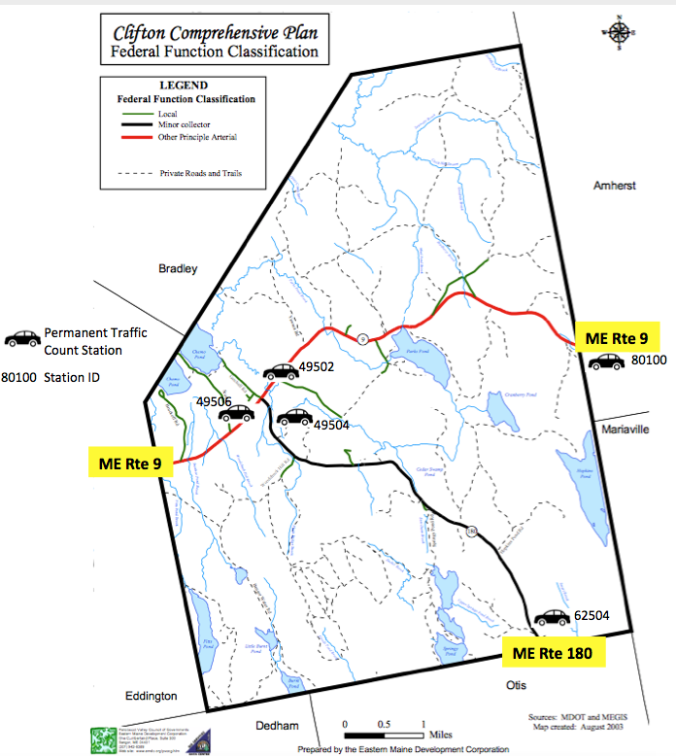
Source: Eastern Maine Development Corporation 2003
PUBLIC ROADS AND WAYS
The table below shows public roads in Clifton. Divided into three categories of road function, they are: arterial, collector, and local. The table also indicates maintenance responsibility or jurisdiction, surfacing, and overall condition for Clifton’s approximately 19 miles of road. The Town is financially responsible to maintain approximately 6.86 miles of the road location. Although Rebel Hill (Route 180) has a federal function classification of minor collector, the town works with this road with an arterial perspective.
Road Name | Length FT/M | Surface | Responsibility | Condition | Federal Function
Airline Road (Route 9) | 34,385/10,481 | Paved | State | Good | Other Principal Arterial
Rebel Hill Road | 28,120/8,571 | Paved | State | Good | Other Principal Arterial
Bobcat Road | 6,997/2,133 | Gravel | Town | Fair | Local
Bruckoff Road | 5,475/1,669 | Paved | Town | Fair | Local
Bruckoff Road Cont'd | 500/152 | Gravel | Town | Fair | Local
Chick Hill Road | 3,478/1,060 | Paved | Town | Fair | Local
Clewley Hill Road | 1,635/498 | Gravel | Town | Fair | Local
Getchell Road | 2,240/683 | Paved | Town | Fair | Local
Getchell Road (2nd Part) | 1,285/392 | Gravel | Town | Fair | Local
McCutcheon Road | 1,040/317 | Gravel | Town | Fair | Local
McLaughlin Road | 613/187 | Paved | Town | Fair | Local
Mill Lane | 1,800/549 | Paved | Town | Fair | Local
Nickerson Hill | 500/152 | Gravel | Town | Fair | Local
North Road | 565/172 | Paved | Town | Fair | Local
Old Stage Coach Road | 3,606/1,099 | Gravel | Town | Fair | Local
Pleasant Lane | 893/272 | Paved | Town | Fair | Local
Scotts Point Road | 6,828/2,081 | Paved | Town | Fair | Local
Woodchuck Hill Road | 250/76 | Gravel | Town | Fair | Local
Source: Maine Department of Transportation; Town Records
PRIVATE ROADS AND WAYS
Clifton’s private roads serve subdivisions, woodlots, camps and individual residences. In some cases, because of the new Enhanced 911 system, private roads include long driveways. A driveway will have a name if it accesses more than one residential structure, to lessen the confusion for emergency personnel. Whatever the case may be, private roads receive their maintenance from a source other than the Town or the State. Since these roads are private, issues with respect to accessibility, maintenance and road standards fall on the responsibility of the association owners and the town limits discussion and responsibility for issues arising from these roads. Following is a listing of the private roads and ways in Clifton.
Road Name | Length Ft/m | Surface | Responsibility | Condition
Bangor Water Works Road | 18,023/5,493 | Paved | Private | Poor to Fair
Beaver Tail Lane | 479/146 | Gravel | Private | Fair
Bobho Road | 487/148 | Gravel | Private | Fair
Bradbury Brook Road | 4,659/1,420 | Gravel | Private | Good
Brooks Lane | 417/127 | Gravel | Private | Fair
Campbell Lane | 1,753/534 | Gravel | Private | Fair
Cedar Lane | 452/138 | Gravel | Private | Fair
Dubay Lane | 351/107 | Gravel | Private | Fair
East Hopkins Pond Road | 1,810/552 | Gravel | Private | Fair
Erickson Road | 1,969/600 | Gravel | Private | Fair
German Cove Road | 1,784/544 | Gravel | Private | Poor
Getchell Road Cont'd | 1,200/366 | Gravel | Private | Fair
Hendrickson Lane | 1,148/350 | Gravel | Private | Fair
Hopkins Pond Road | 8,231/2,509 | Gravel | Private | Fair
Ireland Lane | 381/116 | Gravel | Private | Fair
Journeys End Lane | 703/214 | Gravel | Private | Fair
Lear Lane | 450/137 | Gravel | Private | Fair
Maple Lane | 1,118/341 | Gravel | Private | Fair
Middle Pond Road | 2,990/911 | Gravel | Private | Fair
Mill Lane Cont'd | 2,400/732 | Gravel | Private | Fair
Nickerson Hill Cont'd | 1,000/305 | Gravel | Private | Fair
Outlet Lane | 1,087/331 | Gravel | Private | Fair
Paradise Cove | 284/87 | Gravel | Private | Fair
Parks Pond Lane | 215/66 | Gravel | Private | Fair
Ridge Lane | 4,925/1,501 | Gravel | Private | Fair
Smith Lane | 3,391/1,034 | Gravel | Private | Fair
Spencer Lane | 776/237 | Gravel | Private | Fair
Springy Pond Road | 12,155/3,705 | Gravel | Private | Fair
Thompson Court | 901/275 | Gravel | Private | Fair
Wood Bridge Lane | 628/191 | Gravel | Private | Fair
Birch Hill Lane | 900/274 | Gravel | Private | Fair
Blacks Road | 5,347/1,630 | Gravel | Private | Poor
Brutiss Way | 1,000/305 | Gravel | Private | Fair
Buchanan Lane | 356/109 | Gravel | Private | Fair
Country Lane | 283/86 | Gravel | Private | Fair
Dragon Fly Lane | 625/191 | Gravel | Private | Fair
Fairway Drive | 349/106 | Gravel | Private | Fair
Fickett Mountain Trail | 1,334/407 | Gravel | Private | Fair
FM Farm Road | 1,235/376 | Gravel | Private | Fair
October Way | 600/183 | Gravel | Private | Fair
Pisgah Mountain Road | 8,000/2,438 | Gravel | Private | Fair
Strawberry Lane | 464/141 | Gravel | Private | Fair
Trillium Lane | 3,500/1,067 | Gravel | Private | Fair
Woodchuck Hill Road Cont'd | 2,900/884 | Gravel | Private | Fair
Yawaca Road | 8,699/2,651 | Gravel | Private | Fair to Good
Zachary’s Way | 209/64 | Gravel | Private | Fair
Source: Town Records
In summary, there are 62,505 Ft (19,052 m) of state roads; State 119,363 Ft (36,382 m) of town roads and 149,673 Ft (45,620 m) of private roads.
ROAD MAINTENANCE
The Select Board serves as the Board of Road Commissioners in Clifton and oversees the condition of the roads as a committee. They assume the responsibility of prioritizing road maintenance and road repair.
There is no Public Works Department in Clifton. The town develops projects and statements of work and then advertises the projects for competitive bid. The Town maintains 6.86 miles (11.1 km) of roads year-round within Clifton. The Town performs winter snow plowing and sanding on 12.13 (19.6 km) miles of road, which includes town maintained roads and Rebel Hill Road, a state-owned road (5.27 miles (8.5 km) on Route 180). The table below shows recent history for road maintenance in Clifton.
The Maine Department of Transportation maintains and administers activity for non-local roads. Their authority includes permitting of driveways and entrances, curb cuts, summer and winter maintenance, and traffic flow and safety decisions such as traffic signals, signs, reconstruction and road widening. The Urban-Rural Initiative Program (URIP) requires each municipality to certify that the funds will be used only for capital improvement of public roads. Additionally, the town receives funds through the tax increment finance (TIF) account to perform some types of maintenance, upgrades, or new construction as a result of the Pisgah Mountain Wind Energy project.
Road Expenses (Annual Report) | Calendar Year
 | 2012 | 2013 | 2014 | 2015 | 2016 | 2017
Capital Expenses | $13,701 | $26,162 | $24,120 | $0 | $19,830 | $0
Maintenance | $4,623 | $19,492 | $18,766 | $16,716 | $21,504 | $17,141
Snow Removal | $52,780 | $67,883 | $51,885 | $51,665 | $72,864 | $75,040
Sand and Salt | $35,293 | $36,498 | $35,975 | $36,730 | $51,809 | $31,071

The Maine DOT Local Roads Center provides a “Road Surface Management for Maine Towns” training program, including Road and Sign Management Software (RSMS www.rsms.info). RSMS 10 came online around 2010 as a replacement for the Road Surface Maintenance Software program developed in the 1990s. The software now includes RSM 16, a geographic information system combining data management and mapping. The Town of Clifton should evaluate the cost and complexity of this system to determine if it would help prioritize and plan for improvements and repairs to the town roads.
TRAFFIC COUNTS
Based on the 20 years of available data, the traffic coming through town on Route 9 changed little with a 13% increase from 1996 through 2015. Route 9 traffic decreases from the Eddington town line to the Amherst town line by roughly 2000 (1000 each direction) vehicles in Clifton on an average day with the number turning off or on Route 180 being about 1000 (500 each direction) over the entire period shown. There are 300 trips fewer at the Otis town line than there are at the intersection of Routes 9 and 180 meaning local trips average 150 round trips per day by local traffic on Route 180. This would also imply, few residents who live near Route 180 work or drive towards Ellsworth.

Station | Description | 1996 | 1998 | 2001 | 2012 | 2015 | Delta %
49506 | Rte 9 Prior to Rte 180 | 4,760 | 5,090 | 5,290 | 5,420 | 5,380 | 13.0%
49502 | Rte 9 After Rte 180 | 3,730 | 3,970 | 4,320 | 4,350 | 4,340 | 16.4%
80100 | Rte 9 At East T/L | 2,750 | 3,600 | 4,140 | 3,800 | 3,660 | 33.1%
49504 | Begin Rte 180 | 1,040 | 1,000 | 980 | 1,110 | 1,000 | -3.8%
62504 | Rte 180 @ South T/L | 620 |  | 770 | 790 | 700 | 12.9%

In summary, taking 5,380 (west side) and subtracting 3,660 (east side) equals 1720. One thousand of those trips are on Route 180. Thus there are roughly 350 round trips on Route 9 adding back the 150 round trips on Route 180 (as described above) or a total 500 local traffic round trips per day on the state roads in Clifton.
MAINEDOT ASSESSMENT
MaineDOT is currently assessing all state highways and state-aid roads using a number of physical measures for level of service, safety and condition. The physical measures combine to form ratings using grades A to F for each of the three categories along defined segments of the highways.
Level of Service
In 2014 MDOT rated levels of service for state highways based on three criteria:
• Road posting (typically during the spring thaw)
• Bridge posting
• Congestion
Route 9 received a level of service rating of A throughout; no deficiencies noted with respect to road posting, bridge posting and congestion. Route 180 received a rating of C due to the need for road posting. Both state highways received an A for congestion, suggesting that both roads have significant additional capacity. A congestion rating of C or below would indicate a capacity problem.
Safety
MaineDOT rates all state highways for safety based on:
• Pavement Rutting
• Crash History
• Pavement Width
Route 9 from the Eddington town line to Mill Lane (just west of Parks Pond) received a B rating primarily because of the crash history. Route 9 east of Mill Lane is rated F also due to crash history. Route 180 received a rating of D due to crash history and pavement width. While there is a history of significant number of crashes on Route 9 and Route 180, the frequency is not abnormal for the volume of traffic they carry. A high crash location is a location that exhibits a Critical Rate Factor (CRF) equal to or greater than 1.0 and has experienced at least 8 crashes in the most recent complete 3-year period. The Maine Department of Transportation did not indentify any High Crash Locations in Clifton; crash data shows the majority of crashes occur along the Route 9 corridor, particularly in locations where the highway curves.
The Town considers the intersection of Clewley Hill Road and Rebel Hill (Route 180) to be a hazardous stretch of road due to no shoulders, seasonal drainage issues, and ice problems. In addition, the Town considers all intersections with Airline Road (Route 9) to be potentially hazardous for left turning vehicles (on-coming traffic lane crossing).
Road Condition
MaineDOT rated state highways with respect to physical condition in 2014 based on:
• Pavement Condition
• Ride Quality
• Roadway Strength
• Structure of Bridges
Route 9 received an A rating from the Eddington Town line to Getchell Road (intersection with Route 180); a C to the McCutcheon Road (just west of the Baptist Church) due structural bridge concern over Parks Pond Brook; an A to the Chick Hill Road and a B from there to the Amherst town line (pavement condition concern). Route 180 received an A from Route 9 to Woodchuck Hill Road, then a B to the Otis town line (ride quality).

ACCESS ISSUES ALONG CLIFTON’S ROUTE 9 CORRIDOR
Over the next ten to twenty years the Census Bureau predicts Clifton’s population will decline due to aging and lower birth rates. The long anticipated I-395 connector is starting construction in 2019 and will likely increase in through traffic – possibly by 2,000 cars per day. Clifton may also attract more outdoor and recreational enthusiasts as summer residents and day visitors particularly if the town begins to aggressively market itself as a destination location for these activities. Local trips may decrease with a smaller and older population. Through traffic may increase in volume, vehicle size and speed through Clifton. At the present time Clifton has a level of service rating of A, and no high crash locations or other major safety issues. However safety issues may develop as traffic levels rise along the Route 9 corridor.
Despite overall decreases in population, there may be concentrations where the population will increase particularly on roads accessing dwellings along the ponds. It is increasingly common to convert seasonal housing to year- round residences. Local roads such as Scott Point Road, Getchell Road, Mill Lane, and Bruckoff Road will generate heavier year-round traffic. At this time left-hand turns onto some of these roads is not a safety issue; with the potential of increased traffic they could become a safety concern. Some of these intersections and others may have marginal sight distances for the posted speed and traffic volume.
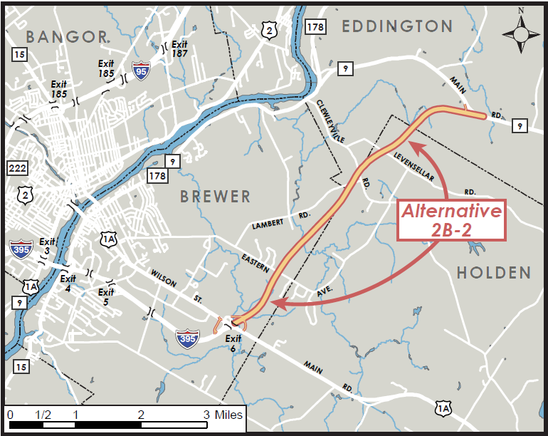
Once the I-395 Connector is complete in 2020, its junction with Route 9 will be in Eddington approximately four miles west of the Clifton town line. Commercial vehicle traffic on Route 9 through Clifton will increase. However, the speed these and other vehicles travel will be a function of volume, congestion and driver comfort. Additional traffic may impact services to Clifton residents such as school bus routes, mail delivery, trash collection, and emergency services. Access management and land use planning at the new interchange may mitigate added congestion on Route 9. The town is unaware of any projections about how additional traffic resulting from the I-395 connector may impact specific organizations or businesses with Route 9 access.

Promotion of the recreational use of Clifton’s natural resources may result in an increase in traffic to the trailheads and lakes within town. Most of these areas are accessed via rural local roads with the exception of Parks Pond Bluff Trail Head accessed directly from Route 9 – with almost no parking room on a curvy knoll with poor sight distances. There is also the potential for recreational bicycle traffic to increase in the future associated with recreation.
The Town will work with the MaineDOT on corridor planning in order to address some of these issues. The Town may request assistance from MDOT to perform a safety analysis of all intersections with Route 9; develop trailhead access/parking along Route 9; research how bicycle traffic may be encouraged without endangering the cyclists or motorists. The Town will request MaineDOT to indicate how current and future traffic flows may be affected by the I-395 connector and what impact traffic flow changes will have on current businesses and services available in Clifton.
BRIDGES AND CULVERTS
There are three bridges in Clifton, all owned and maintained by the State. The Table below describes the bridges. Map 10-5 shows the location of bridges in the town of Clifton.
TOWN OF CLIFTON BRIDGE INVENTORY
Bridge Name | Bridge Number | Year Built | Owner | Last Inspection | Condition |  | Fed Sufficiency Rating
Lower Bridge (Parks Pond Brook; AKA Mill Stream | 3522 | 1929 | MDOT | 11/29/2016 | Deck | Satisfactory (6) | 61
 |  |  |  |  | Super Structure | Satisfactory (6)
 |  |  |  |  | Substructure | Fair(5)
Otis Road Bridge | 5440 | 2003 | MDOT | 1/5/2018 | Deck | Culvert/NA | 96
 |  |  |  |  | Super Structure | Culvert/NA
 |  |  |  |  | Substructure | Culvert/NA
Plank Brook Bridge | 5415 | 1993 | MDOT | 11/29/2016 | Deck | Satisfactory (6) | 77
 |  |  |  |  | Super Structure | Satisfactory (6)
 |  |  |  |  | Substructure | Satisfactory (6)

A bridge “federal sufficiency rating" calculation weights 55% on the structural evaluation, 30% on the obsolescence of its design, and 15% on its importance to the public. As of 2008, a score of 80 or less creates a federal funding request repair justification, and 50 or less will make the bridge eligible for federal replacement funding.
SIDEWALK/PEDESTRIAN/BICYCLE FACILITIES
Clifton has no sidewalks, bike paths, cross walks, or other areas designed to aid pedestrians and cyclists. Despite the fact that there are no bike paths in Clifton, groups of cyclists regularly ride routes between Pat’s Bike Shop in Brewer and either the Rebel Hill or Chick Hill areas in Clifton. These cyclists use the paved shoulders of Airline Road (Route 9) and the driving surface of Rebel Hill Road (Route 180).
PUBLIC TRANSPORTATION
Clifton does not have a public transportation system. At present, population trends show no cost-effective opportunity for public transportation. Taxi service is available from Ellsworth, Bar Harbor, Bangor or Brewer. Several transportation network service companies (TNC) also sometimes called mobility providers, including Uber and Lyft are also available in the area.
The LYNX is a program of the Penquis Community Action Program (Penquis CAP-www.penquis.org), funded in part by the Maine Department of Transportation and the Maine Department of Human Services, Bureau of Medical Services, which provides transportation services for residents of Penobscot and Piscataquis Counties. Door to door transportation for eligible riders is made by appointment weekdays from 8:00 a.m. to 4:30 by calling 973-3695.
Transportation is by vans and buses; private vehicles; or family members are directly reimbursed for Medicaid covered services. Services are for the general public; special services for the elderly; Medicaid recipients; other social service clients by agency contract; and serves as a paratransit provider for The BAT or Bangor Area Transportation.
REGIONAL TRANSPORTATION
Airports
There are no airports or public airfields within the Town of Clifton. Primary regional airports include:
Bangor International Airport, is the nearest airport located in Bangor. The airport provides national and international commercial passenger and freight services, as well as civil defense operations. The airport has an 11,441-foot main runway. Car rental services are available.
Hancock County - Bar Harbor Airport in Trenton has regularly scheduled passenger commercial service. In addition to daily commuter service to Boston, Massachusetts, charter service is offered. Car rental services are available. The airport has a 5,200-foot main runway.
Bus Service
There is no public city or intercity bus service in Clifton. However regional bus services include:
Cyr Bus Lines is the nearest bus company. It is a full service transportation company and tour operator located in Old Town. Cyr Bus Line offers daily scheduled service between Bangor and Aroostook County. Cyr Bus Lines also features a fleet of modern school buses and deluxe motorcoaches, available for both charter and lease. Cyr Bus Tours, the tour operations division of the company, offers tour packages to Atlantic Canada and the Eastern United States.
Concord Trailways is Northern New England’s largest intercity bus carrier. The Express Service provides multiple daily service from 1039 Union Street in Bangor to Portland, Boston’s South Station and Logan Airport. In addition, Concord Trailways also provides pick up and drop off service directly to the University of Maine.
Greyhound Bus Lines provides service nationwide. Greyhound Lines, Inc. offers multiple daily departures to Portland and Boston originating at Dysarts Restaurant at 530 Cold Brook Road in Hermon.
BAT Community Connector is a fixed route public transit system operated by the City of Bangor for the communities of the Greater Bangor Urbanized Area. They include Bangor, Brewer, Veazie, Orono, Old Town, and Hampden. The Bus also provides service to the University of Maine. The City of Bangor supplies service to these communities on a contractual basis. BAT Community Connector base of operation is in Bangor.

ACCESS MANAGEMENT
Access management is the planned location and design of driveways and entrances to public roads, and land uses, to help reduce accidents and prolong the useful life of an arterial. Arterial highways, including Route 9, represent only 12% of the state-maintained highway system, but carry 62% of the statewide traffic volume. Maintaining posted speed limits on the system means assisting the flow of people, goods and services to move faster, which enhances productivity, reduces congestion-related delays and environment degradation. By preserving the capacity of the current system, the need to build costly new highway capacity such as new travel lanes and bypasses will be reduced in the future. Currently, Clifton has no ordinances making access management stricter than that mandated by the state.
CORRIDOR PLANNING
The purpose of corridor planning is to develop a regional approach for corridor management. Corridor planning is necessary for the continued efficient movement of traffic. Corridor planning is directly related not only to mobility, but also to economic activity and regional mitigation efforts that are necessary for the vitality of the area. It is important for neighboring communities to recognize the importance of corridor planning and to work together to create a regional access management master plan.
Arterial State Route 9 bisects the town horizontally and State Route 180 transects vertically. These two state highways carry most of the traffic volume in Clifton and receive significant state and federal funding. MaineDOT published a report, Public Involvement in Transportation Planning in 2015. This document provides guidance for municipal participation in corridor planning. The town should work with MDOT to whenever corridor plans are updated.
In 2016 MDOT and the Federal Highway Administration (FHWA) approved construction of the I-395 connector as illustrated above. The connector completes a bypass around Bangor and Brewer commercial districts significantly reducing travel time for through-traffic. The interchange between Route 395 and Route 9 is proposed to be close to the Meadow Brook crossing in Eddington, approximately 4.2 miles west of the Clifton town line.
Commercial vehicle traffic on Route 9 through Clifton should increase. The speed at which drivers choose to travel remains unknown; the location of this intersection and the traffic flow caused by it may impact services to Clifton residents such as school bus routes, mail delivery, trash collection, and emergency services.
The I-395 connector road will likely impact land use adjacent to Route 9. The proposed interchange between I-395 and Route 9 may encourage commercial strip development along the highway in the westerly portion of the town. Strip type development will have negative impacts both on safety and mobility on Route 9 and erode the arterial’s capacity to function as a safe and efficient interstate commerce route. The Town of Clifton may work with the Towns of Eddington, Amherst and MaineDOT to develop a corridor plan managing development along the highway corridor and adopt access management performance standards in a future land use ordinance update.
STRATEGIES and POLICIES
The Town implemented all land use and coordination strategies recommended in the last Comprehensive Plan. The town is now in sustainment mode and with the Tax Increment Financing funds available, town roads and other transportation planning type funding related to enhancing economic goals is available.
The overarching policy statement for Clifton regarding transportation is:
The two primary boards managing the town’s business processes, financial assets, and land use governance will actively sustain motor vehicle infrastructure while expanding recreational access to bicycles and regional walking trail networks and also improving accessibility to regional passenger services to better support the identified vulnerable families in the community.
The eight major strategies will be:
The Select Board will continue to appoint and upgrade train at least one member to be an effective Road Commissioner responsible for planning, scheduling, and contracting oversight.
The Select Board will continue to make use of the TIF and property taxes for revenue sources on par with anticipated and nominal, historically based contingency consumption to sustain Town roads.
The Select Board will ensure the Code Enforcement Officer monitors development and land owner practices to ensure activities do not encroach or cause harm to Town roads.
The Planning Board will continue to review projects and update the land use ordinance when necessary to ensure protection of community transportation system assets and public safety particularly as the by-pass corridor comes on line with the predicted 2,000 vehicle per day increase.
The Planning Board will work with developers and landowners when possible to coordinate new access to existing trail networks and also to promote new non-motorized trail networks.
The Select Board and Planning Board will jointly consider opportunities to further expand or use the existing snow mobile trail network to enable economic growth.
The Select Board and the Planning Board will jointly consider whether it is appropriate, in the Town or community interest, or even feasible to encourage connectivity with the regional all terrain vehicle network.
The Select Board will consider options, protecting individual confidentiality, to investigate the level of need or capacity to assist vulnerable households with improved access (ground transportation services) to regional economic centers (Bangor, Brewer, Ellsworth).

