STATE GOAL
Maine strives to:
protect the quality and manage the quantity of the State’s water resources, including lakes, aquifers, vernal ponds, great ponds, estuaries, rivers and coastal areas;
protect the State’s other critical natural resources, including without limitation, wetlands, wildlife and fisheries habitat, sand dunes, shorelands, scenic vistas and unique natural areas;
WATER RESOURCES
Water resources include surface water bodies (lakes, ponds, brooks, streams) and known sand and gravel aquifers (groundwater). These resources are illustrated on the Aquifers, Watersheds and Wetlands Map. The Town protects water resources via the Shoreland Zoning portion of the Clifton Land Use Ordinance (CLUO). For many years Clifton had a stand-alone Shoreland Zoning Ordinance first adopted in 1992; amended multiple times over the past 20 years, the current regulations are within the 2017 CLUO. The information contained herein is for reference only; for official and enforceable regulations (and locations), refer to the most current version of the CLUO.
WATER QUALITY CLASSIFICATION
The State has four classes for freshwater rivers, three classes for marine and estuarine waters, and one class for lakes and ponds. A close comparison of the standards will show that there is actually not much difference between the uses or the qualities of the various classes. All attain the minimum fishable-swimmable standards established in the Federal Clean Water Act. Most support the same set of designated uses with some modest variations in their descriptions.
The classification system should be viewed as a hierarchy of risk, more than one of use or quality, the risk being the possibility of breakdown of the ecosystem and the loss of use due to either natural or human-caused events. Ecosystems that are more natural in their structure and function can be expected to be more resilient to a new stress and show more rapid recovery. Classes AA, GPA, and SA involve little risk since activities such as waste discharge and impoundment are prohibited. The expectation to achieve natural conditions is high and degradation is unlikely. Class A waters allow impoundments and very restricted discharges, so the risk of degradation while quite small, does increase since there is some small human intervention in the maintenance of the ecosystem. Classes B and SB have fewer restrictions on activities but still maintain high water quality criteria. Classes C and SC waters are still good quality, but the margin for error before significant degradation might occur in these waters in the event of an additional stress being introduced, (such as a spill or a drought) is the least.
Maine Revised Statutes Title 38 Sections 464(2), 464(2-A) and 464(3) governs reclassification of waters of the State. This statute requires the Department of Environmental Protection to conduct water quality studies, and the Board of Environmental Protection to hold hearings and propose changes to the water classification system to the Legislature for final approval. This occurs from time to time and generally every three to five years. The last reclassification resulting in changes enacted in 1999. Clifton’s rivers and streams meet the criteria for Class A or Class B.
WATER QUALITY MONITORING REPORT
The Maine Department of Environmental Protection (MDEP) provides monitoring reports for variables most often used to measure the water quality of Maine’s lakes and ponds. The Volunteer Lake Monitoring Program (https://www.lakesofmaine.org/index.html) and staff from MDEP observe the readings and generate the data.
Total phosphorus is one of the major nutrients needed for plant growth. It is generally present in small amounts and limits the plant growth in lakes. Measured in parts per billion (ppb), as phosphorus increases, the amount of algae also increases. Total Phosphorus varies from 1 ppb to 110 ppb with the average being 14 ppb.
Secchi Disk transparency is a measure of the water clarity, or transparency of the lake. All Secchi Disk readings are in meters. Factors reducing clarity are algae, zooplankton, water color and silt. Since algae are the most abundant item, measuring transparency indirectly measures the algal productivity. Secchi disk readings indicate change in water quality over time. Transparency values in Maine vary from .04 meters to 20.0 meters, with the average being 4.9 meters. Unless a lake has high coloration (high concentration of natural dissolved organic acids such as tannins and lignins, giving water a tea color), a transparency of 2 meters or less indicates a water quality problem resulting in an algal bloom. In Maine, the mean Secchi disk readings relate to algal productivity using the following guidelines: Productive – 4 meters or less; Moderately Productive – 4.1-7.9 meters; Unproductive 8 meters or greater.
Trophic State Index (TSI) is a scale ranking lakes from 0 (desirable, not good for algal blooms) to 100 (not desirable, great for algal blooms). TSI for a year is only valid when there are at least five months of data. Lakes with TSI values greater than 60 (less than 2 meters Secchi disk reading) may support blooms. Lakes with TSI values over 100 indicate extreme productivity and annual algae blooms. TSI values are useful for comparing lakes with similar water-color and to track water quality trends within a lake.
WATERSHEDS
A watershed is a geographic region where water drains into a particular river, stream or body of water and includes hills, lowlands, and the body of water where the land drains. Approximately 50% of the land area in the State of Maine is part of a lake watershed.
All waters connect: pollution to one source will affect another within a watershed. It is important to remember everything occurring in a watershed and everything transportable by water will eventually reach and impact the water quality of a water body. In other words, these activities may disturb the watershed. The disturbed and developed land contributes pollutants and other substances to a lake. Activity anywhere in a watershed, even several miles away, has the potential to impact lake water quality.
Because Clifton has within its boundaries 23 brooks and 11 Great Ponds, it is possible to delineate 28 watersheds or drainage areas within the town. Note there is a major drainage divide bisecting the town. All surface water north of the divide flows north and west toward the Penobscot River, while all surface water south of the divide flows south and east toward the Union River. Of the eleven ponds, over half (Parks, Cranberry, Cedar Swamp, Little Burnt, Snowshoe, and Upper/Middle Springy) have their entire direct watersheds within the boundaries of Clifton. The remaining pond watersheds share jurisdiction and land use patterns with the municipalities bordering Clifton.
Clifton Shoreland Zoning Regulated Water Bodies
NAME | WATERSHED MUNICPALITIES | LOCATION | ZONE TYPE
Chemo Pond | Clifton, Bradley, Eddington | Northwest corner | LR, RP
Parks Pond | Clifton | Central/South of Rte. 9 | LR, LC, RP
Hopkins Pond | Clifton, Mariaville | Southeast corner | LR, RP, LC
Cranberry Pond | Clifton | Central/E of Rte. 180 | LR,RP
Cedar Swamp Pond | Clifton | Central/E of Rte.180 | LR
Springy Ponds (Upper, Middle, Lower) | Clifton, Otis | South central/W of Rte. 180 | LR, RP
Burnt Pond | Clifton, Dedham, Otis | Southwest border | LR
Little Burnt Pond | Clifton | Southwest border | LR, RP
Fitts Pond | Clifton, Eddington | Southwest border | LR, RP
Snowshoe Pond | Clifton | Southwest | LR
Snowshoe Pond Brook | Clifton | Southwest | SP
Fitts Pond Brook | Clifton | Southwest | SP
Woodchuck Hill Brook | Clifton | Southwest | SP
Plank Bridge Brook | Clifton | Southwest | SP
Sibley Brook | Clifton | Central | SP
Parks Pond Brook | Clifton | North | SP
Mud Pond Brook | Clifton | North of Rte. 9 | SP
Otter Creek Brook | Clifton | North of Rte. 9 | SP
Bradbury Brook | Clifton | North of Rte. 9 | SP
Chick Hill Stream | Clifton | North of Rte. 9 | SP
Goodwin Brook | Clifton | North of Rte. 9 | SP
Intervale Brook | Clifton | North of Rte. 9 | SP
Great Works Stream | Clifton | North of Rte. 9 | SP
Saddleback Brook | Clifton | North of Rte. 9 | SP
Little Burnt to Burnt Pd. Bk. | Clifton | South | SP
Floods Pond Brook | Clifton | South | SP
Sucker Brook | Clifton | South | SP
East Dunn Brook | Clifton | South | SP
Upper Springy Pond Brook | Clifton | South | SP
Dumb Brook | Clifton | Southeast | SP
Smart Brook | Clifton | Southeast | SP
Cedar Swamp Brook | Clifton | Central | SP
Cranberry Pond Brook | Clifton | Central | SP
Key: Zone Types: Resource Protection (RP) Limited Residential (LR) Limited Commercial (LC) Stream Protection (SP)
Refer to the most recent CLUO for jurisdictional and regulatory guidance for all water bodies.
LAKES AND PONDS
Among Maine’s most significant natural resources are its lakes and ponds. Fisheries, wildlife, recreation, scenic views and water supply are all benefits that the citizens of Maine and its visitors derive from the 5,779 lakes and ponds here. Development activities, such as house and road construction, timber harvesting and agricultural practices, disturb the land that is drained to a lake by streams and ground water (the watershed).
WATER BODY | WATER QUALITY  (2018 Lakes of Maine Web Site)
Burnt Pond | Not Available
Little Burnt Pond | Not Available
Cedar Swamp Pond | Not Available
Chemo Pond | Below Average
Cranberry Pond | Not Available
Fitts Pond | Not Available
Hopkins Pond | Above Average
Springy Ponds (Upper/Middle and Lower) | Above Average
Parks Pond | Above Average
Snowshoe Pond | Not Available

Burnt Pond
Burnt Pond has an area of approximately 316 acres, an elevation of 320 feet and a maximum depth of 27 feet. Secchi disk readings estimate an average of 6 ppb for total phosphorus; with minimum average Secchi disk readings of 5.4 meters and maximum average Secchi readings of 7.5. The average trophic state index is 36. Although most recent data are from 1990, so the status of the Pond may have changed in that time, available data indicates that Burnt Pond has clarity that indicates algal blooms are moderately productive to unproductive.1
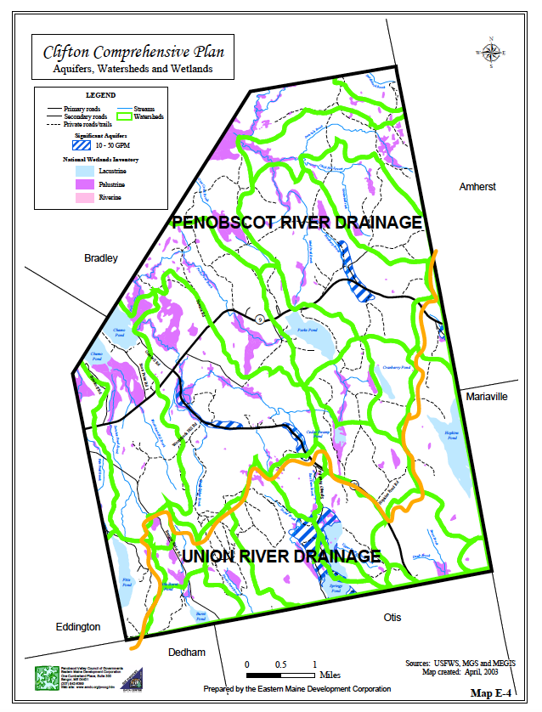

Chemo Pond
Chemo Pond has an area of approximately 1,146 acres, an elevation of 126 feet and a maximum depth of 24 feet. Chemo Pond is a shallow warm water pond providing excellent habitat for sport fishing species such bass, white perch, and pickerel. Other fish species occasionally found in Chemo Pond include brook trout, smallmouth bass, white perch, yellow perch, chain pickerel, hornpout, eel, white sucker, minnows and sunfish. The production of bass food is high and suitable spawning areas are present. Fishermen occasionally report taking trout.
In recent years, various groups lobbied and developed a public information campaign regarding a fish species called alewives (Alosa pseudoharengus). The Maine Legislature supported removing dams and other measures to mitigate the influence of man over the past 400 years to re-enable anadromous migration. In short, alewives are a seasonal fish situated somewhere between white suckers and creek chubs – bait fish. Spawning areas have deposits of sperm and eggs from the 60,000 to 467,000 eggs produced annually by each female with average life spans of seven to eight years. Theoretically, these eggs and sperm are protein packets for lower aquatic animals such as zooplankton, bryozoans, clams, and insect larvae.
That said, Blackman Stream (the outlet to the north) has become one of the largest spawning grounds on the east coast of the United States for alewives with electronic counts now exceeding over 600,000 each season. Many of these alewives come up to Chemo Pond to spawn. While there were early concerns about alewives competing with sport species, according to scientists, alewives do not eat during spawning season until they return to the brackish Penobscot River waters. The species is valuable for lobster bait, pet food, and fertilizer (nitrogen rich) among other products.
Some people living in the area or visiting the pond for decades do not agree the alewives are a good for Chemo Pond. They indicate fewer game fish are available and in fact, there are fewer fishing derbies in Chemo now than ten or twenty years ago when they were routine. There are no formal studies on Chemo Pond to prove down turns in game fish capture or other positive or negative impacts resulting from the alewives.
The Secchi Data summary for Chemo Pond indicates historical (from 1984-1995) readings estimate an average of 25 ppb for total phosphorus; with minimum average Secchi disk readings of 2.5 meters and maximum average Secchi readings of 4.1. Recent studies by the Lake Volunteers indicate poor water quality for Chemo Pond.
Fitts Pond
Fitts Pond has an area of approximately 106 acres, an elevation of 320 feet and a maximum depth of 64 feet. Fitts Pond is a small, deep, oligotrophic lake (relatively low in plant nutrients and containing abundant oxygen in the deeper parts) situated at the base of Blackcap Mountain in Clifton. Access to the Pond is via the road to the Katahdin Area Boy Scout Camp on the western shore. Although chain pickerel are present in the Pond, they are small with limited habitat. Other fish species found in the Pond include splake, smelt, eel, minnows, ninespine stickleback, pumpkinseed sunfish and redbreast sunfish. This pond supports a principal fishery for splake - being stocked each spring. Restrictive regulations are in effect to take advantage of the ponds potential to grow larger than average splake. Anglers have caught some 3 to 3 1/2 lb fish. Pickerel, most of which are small, are scarce due to lack of suitable habitat. The pond receives moderate use in the winter and spring. The outlet drains into Chemo Pond, and a few splake, which periodically drop down out of Fitts Pond, may be caught in the stream or Chemo Pond.
Parks Pond
Parks Pond has an area of approximately 124 acres, an elevation of 257 feet and a maximum depth of 28 feet. Somewhat dated water quality testing indicates a historical average of 8 ppb for total phosphorus; with minimum average Secchi disk readings of 3.4 meters and maximum average Secchi readings of 6.4. The average trophic state index is 51. Available information indicates algal blooms can be productive to moderately productive; though currently the index indicates above average water quality.
In addition to those Ponds listed above, Clifton has several other ponds as mentioned in the table below.
TOWN OF CLIFTON
LAKE AND POND RECREATIONAL RESOURCE
Name | Elev. (ft) | Area (ac) | Depth (ft) | Splake | Brk Trout | Lake Trout | Smelt | S.M. Bass | W. Perch | Pickerel | Pub. Boat Launch | Priv. Boat Launch
Burnt Pond | 320+ | 316 | 27 |  | X
Chemo Pond | 126 | 1,146 | 24 |  |  |  |  | X | X | X |  | X
Fitts Pond | 318 | 106 | 64 | X |  |  | X |  |  | X |  | X
Hopkins Pond | 361 | 442 | 65 |  | X | X | X
Little Burnt Pond | 378 | 15 | 3
Lower Springy Pond | 277 | 114 | 44 | X | X |  | X |  | X | X |  | X
Parks Pond | 257 | 124 | 28 |  |  |  |  | X | X | X |  | X
Cedar Swamp Pond | 310+ | 20
Cranberry Pond | 340 | 32
Snowshoe Pond | 367 | 8
Upper &Middle Springy Pond | 277 | 124  33  47
Source: Inland Fisheries and Wildlife (1973 & older surveys) and DeLorme Mapping Co.

FLOODPLAINS
The primary function of floodplains is to accommodate floodwater. A floodplain may also absorb and store large amounts of water, later becoming a source of aquifer recharges. Floodplains also serve as wildlife habitats. The Federal Emergency Management Agency (FEMA) has mapped flood plains as defined by the 100-year or base flood, which has a 1% chance of being equaled or exceeded in a given year. Floodplain soils indicate where flooding occurred in the past. Unless a recent or site specific hydro geological study is available to prove flooding is not occurring in recent times, areas of floodplain soils generally undergo the same requirements as flood plains. CLUO currently protects most floodplain areas. These soils do not support industrial or commercial development, and will support light use residential development only with engineering controls. As the CLUO undergoes continuous review and update, requirements should continue to discourage intensive development in floodplains, flood prone areas and “special flood hazard areas.” In addition, the CLUO should also limit expansion of existing development and incompatible land use activities. The State reports Clifton has very few properties within the A Zone with flood insurance policies with no claims made on these policies to date. The Town began participation in the National Flood Insurance Program in May 1994. The map on the next page depicts the approximate location of Clifton’s flood areas.
FRESHWATER WETLANDS
The term “wetlands” is defined under both state and federal laws as “those areas that are inundated or saturated by surface or groundwater at a frequency and duration sufficient to support prevalence of vegetation typically adapted for life in saturated soils.” Wetlands include freshwater swamps, bogs, marshes, heaths, swales, and meadows.
There are three separate designations for wetlands: Lacustrine, Palustrine, and Riverine. The Lacustrine System includes wetlands and deep-water habitats with all of the following characteristics: (1) situated in a topographic depression or a dammed river channel; (2) lacking trees, shrubs, persistent emergent, emergent mosses, or lichens with greater than 30% areal coverage; and (3) total area exceeds 20 acres. Similar wetland and deep-water habitats totaling less than 20 acres are also included in the Lacustrine System if an active wave formed or bedrock shoreline feature makes up all or part of the boundary, or if the water depth in the deepest part of the basin exceeds 6.6 feet at low water. Lacustrine waters may be tidal or non-tidal, but ocean-derived salinity is always less than 0.5 parts per thousand (ppt).
The Palustrine System includes all non-tidal wetlands dominated by trees, shrubs, persistent emergent, emergent mosses or lichens, and all such wetlands that occur in tidal areas where salinity due to ocean-derived salts is below 0.5 ppt. It also includes wetlands lacking such vegetation and including four characteristics: (1) area less than 20 acres; (2) active wave-formed or bedrock shoreline features lacking; (3) water depth in the deepest part of basin less than 6.6 feet at low water; and (4) salinity due to ocean-derived salts less than 0.5 ppt.

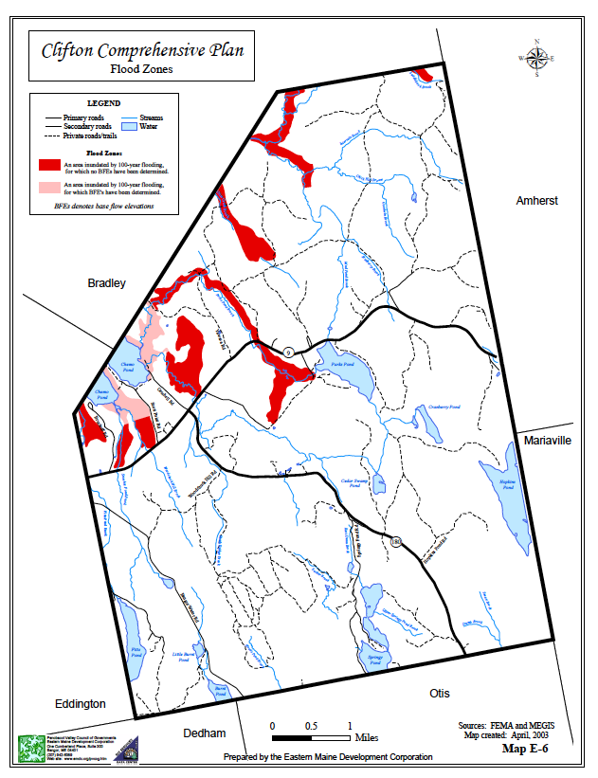

The Riverine System includes all wetlands and deep water habitats contained within a channel, with two exceptions: (1) wetlands dominated by trees, shrubs, persistent emergent, emergent mosses, or lichens, and (2) habitats with water containing ocean-derived salts in excess of 0.5 ppt. A channel is “an open conduit either naturally or artificially created which periodically or continuously contains moving water, or which forms a connecting link between two bodies of standing water.”
Wetlands are valuable for their beauty, recreation opportunities they support, and most importantly for critical functions they perform in our environment. Wetlands are vital to natural systems including water storage, flood conveyance, groundwater recharge and discharge, shoreline erosion control and water quality improvement. Wetlands are important to the public health, safety and welfare because they act as a filter both absorbing excess water and pollutants; serve as aquifer discharge areas; and provide critical habitats for a wide range of fish and wildlife.
Wetlands are fragile natural resources. Even building on the edge of a wetland can have significant environmental consequences. Some wetlands have important recreational and educational value providing opportunities for fishing, boating, hunting, and environmental education. Planning efforts should develop constraints to protect these areas.
The DEP identified freshwater wetlands located within Clifton, as illustrated on the map back on page 6. Initially identified by aerial photo interpretation scientists then ground-truthed the wetlands by soil mapping and other wetland identification techniques. For projects coming in front of the Code Enforcement Officer or Planning Board, site specific field verification is part of the current CLUO and should continue to be a requirement. Wetland alterations (e.g. filling) can contribute to wetland loss. The most common source of alterations includes commercial, residential and urban development; transportation and roads; floodplain development; pollution; timber harvesting; and agriculture.
THREATS TO WATER QUALITY
Point Source Discharge
Point Source discharges of pollution originate from municipal and industrial facilities, bypasses and overflows from municipal sewage systems, unpermitted and illegal dischargers, and produced water from oil and gas operations. Failing residential sewage systems are dealt with as they occur with CEO permitting and enforcement.
Non-Point Source Pollution
Pollution from non-point source include agricultural run-off, both animal wastes and fertilizers, landfills, sand and salt storage, waste lagoons, roadside erosion, leaking underground storage tanks, and hazardous substances. Identification and regulation of these sites are important in safeguarding both surface and ground waters.
Phosphorus is a major threat to the quality of Maine's water resources. Phosphorus is a natural element found in rocks, soils, and organic material. However, human activities (especially lawn and garden fertilization) contribute much higher levels of phosphorus to water bodies than nature does. Phosphorus overloading and the resulting algal blooms have been a major cause of eutrophication in lakes and ponds throughout Maine.
Phosphorus does not pose a significant threat to the water bodies in Clifton at this time. Most ponds located within Clifton have average or better water quality with the outstanding exception of Chemo Pond with poor water quality. Phosphorous may pose a threat to Chemo Pond and rather than develop wider requirements for the entire town, if the town deems it appropriate to develop phosphorous regulations, the Chemo Pond watershed should be the target of such requirements. The state reviews phosphorous allocations for water bodies periodically and should there be a desire to evaluate metric based criteria, consult with the MDEP and an experienced environmental engineer or land development specialist.
Many seemingly harmless activities added together can cause phosphorus overloads. A residential housing development, for example, may contribute up to ten times the natural concentration of phosphorus to storm water runoff during the construction phase and also long after the development stabilizes. Higher levels of phosphorus result by eliminating natural filters and sponges (such as trees, bushes, and grassy surfaces) and by creating impermeable surfaces such as driveways, rooftops, and roads. The solution is to create smaller developments and leave a vegetated “buffer” zone around the water body to filter out phosphorus and other dangerous contaminants from the storm water runoff.
Invasive Aquatic Plants
Invasive aquatic plants are a real and serious threat to Maine’s lakes, ponds, rivers, and streams. These alien plants are not native to Maine waters. When introduced, they out-compete beneficial native plants, spread rapidly, and interfere with navigation. Boating activity is the primary way in which plants spread from one waterbody to another. Plant parts carried on boats, motors, trailers, and fishing gear from an infested water body to one that is not, can lead to disaster.
Plants can survive out of the water for days. Once introduced to a water body they can spread rapidly and become a major nuisance. There is NO known METHOD of eradicating invasive aquatic plants once they have become established. Under Maine law, it is now illegal to transport ANY aquatic plant on the outside of a vehicle. It is illegal to sell, propagate, or introduce to Maine waters any of the eleven invasive aquatic plants. Violation of this law can result in fines. For more information about invasive aquatic plants in Maine, visit http://www.maine.gov/dep/water/invasives.
Invasive Aquatic Plants include the following:
Eurasian water milfoil (Myriophyllum spicatum) | Variable-leaf water milfoil (Myriophyllum heterophyllum)
Parrot feather (Myriophyllum aquaticum) | Water Chestnut (Trapa natans)
Hydrilla (Hydrilla verticillata) | Fanwort (Cabomba caroliniana)
Curly-leaf pondweed (Potamogeton crispus) | European naiad (Najas minor)
Brazilian elodea (Egeria densa) | Frogbit (Hydrocharis morsus-ranae)
Yellow floating heart (Nymphoides peltata)

AQUIFERS
Maine defines an aquifer as a geological unit capable of containing a usable amount of ground water. Aquifers are subsurface water supplies that yield useful quantities of ground water to wells and springs. Aquifers may be of two types: bedrock aquifers and sand and gravel aquifers.
In a bedrock aquifer, groundwater is stored in fractures in the rock; areas with a large number of fractures may contain significant amounts of water. A bedrock aquifer is adequate for small yields. Fractures are sufficiently abundant to provide enough water for a single- family home most everywhere in Maine, and most domestic water supplies are wells drilled in bedrock.
A sand and gravel aquifer is a deposit of coarse-grained surface materials that, in all probability, can supply large volumes of groundwater. The sand and gravel deposits of Maine result from the action of glacial ice and melt water. Boundaries are based on the best-known information and encompass areas that tend to be the principal groundwater recharge sites. Recharge to these specific aquifers, however, is likely to occur over a more extensive area than the aquifer itself.
It is important to protect groundwater from pollution and depletion. Protecting groundwater resources and preventing contamination are the most effective and least expensive techniques for preserving a clean water supply for current and future uses. Clifton’s LUO includes Shoreland Management Area zoning to protect surface waters and Special Protection Areas zoning to protect ground water aquifers.
There are four significant freshwater aquifers within the boundaries of Clifton (see map below). All of these significant aquifers pump between 10 and 50 gallons per minute. One of the aquifers is along Bradbury Brook and underlies a section of the Chick Hifll Road and a small portion of Route 9. Two of the aquifers underlie the Rebel Hill Road (Route 180). The first Rebel Hill aquifer follows the gravel ridge between Sibley Brook and Clewley Hill Road for approximately 1.5 miles. The second Rebel Hill aquifer begins nearly 2.25 miles from Route 9 on Route 180 and continues for 0.7 miles, ending just before the Springy Pond Road junction with Route 180. The fourth aquifer runs along the western shore of Upper/Middle Springy Pond.
Clifton also has a saltwater aquifer under Chemo Pond in the area of the Scott Point and Getchell roads. The saltwater was trapped in blue clay deposits when the ocean covered coastal Maine after glacial melt (circa - 13,000 years ago). Residents attempting to drill wells through the blue clay repeatedly tapped into this trapped seawater finding sodium levels as high as 2,000 parts per million (250 is the drinking water limit). Wells with high salt content are typically on lakefront property below 250 feet elevation, or near wetlands (also below 250 feet). Much of the region to the immediate east and southeast of Chemo Pond is underlain by this aquifer and is therefore less suited to development, unless and until fresh water can be piped into the area.
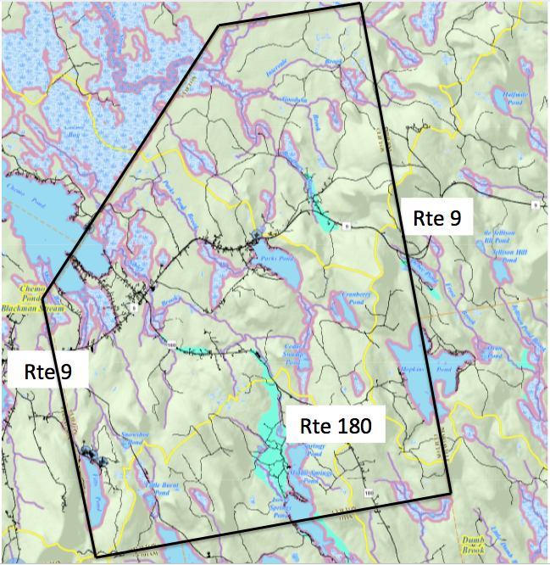
Clifton aquifers shaded in the color aqua based on mapping from the Maine Office of GIS.
DAMS
One known dam exists within the Town of Clifton located on Parks Pond Stream just as it exits from Parks Pond functioning to maintain the water level in Parks Pond. Time of construction is not available; however, records indicate a dam at or near this location since the first “mill” by S. Hammond sometime during the mid-1800’s. Without this dam, Parks Pond would be smaller and shallower, thereby reducing the value of its shoreline and functionality for aquatic life as well as being a historic recreational destination asset for the town. At this time there is no hydrological data indicating the quantity of water held back by the dam, or what impact a breach in the dam would have on the downstream area. Several residences are a short distance downstream of the dam and may suffer adverse effects from a sudden breach. Also, periodic downstream beaver activity in the flowage floods part of the area normally dissipating water capacity if there were a dam breach.
POTENTIAL CONTAMINANTS TO GROUNDWATER
The CLUO protects a majority of the groundwater resources within the Town of Clifton. The freshwater aquifers are the resource most threatened at this time, especially since these aquifers supply private wells throughout the Town. Over development or improper development within an aquifer’s recharge area may allow contaminants to enter the groundwater. Paved roads, gravel pits, chemical and hazardous material storage (including fuel), and disruption or deforestation of large tracts of land are examples of development activities worth monitoring with an eye towards regulating should they cause stress on water resources. Clifton does not have a Public Works Department. Contractors are required to follow Maine DEP guidelines to prevent both surface and ground water pollution. Salt/sand pile maintenance is conducted inside a sand shed.
Once groundwater contamination occurs, it is difficult and sometimes impossible to clean. Possible causes of aquifer contamination include faulty septic systems, road salt leaching into the ground, leaking above ground or underground storage tanks, agricultural run-off of animal waste, auto salvage yards, and landfills. For anyone interested, research the ground water issues in Plymouth, Maine (comparable to Clifton in size and culture) to see what can happen if a disaster occurs.
MAINE DRINKING WATER PROGRAM
The State of Maine Drinking Water Program (DWP) is responsible for enforcing the Federal Safe Drinking Water Act in Maine and has primary responsibility for administering the State’s Rules Relating to Drinking Water. The DWP receives funding from both the United States Environmental Protection Agency and the regulated community. Public water suppliers pay an annual fee which was developed by the DWP, Maine Rural Water Association (MRWA), and the Maine Water Utilities Association (MWUA). This cooperative funding effort was developed to allow Maine companies to be regulated by Maine regulators. The DWP regulates over 2,200 public water systems in Maine.
PUBLIC DRINKING WATER SUPPLY
The Town of Clifton does not have a municipal public drinking water supply. However, there are two wells classified by the Maine Drinking Water Program as public supply sources. One of the wells serves the Katahdin Scout Reservation, Camp Roosevelt. This is a 140-foot drilled well, with a groundwater source. The second is a 400-foot drilled well, also with a groundwater source. This source is located at the Parks Pond Campground.
While Clifton does not have a public drinking water supply, a portion of the Floods Pond (the drinking water supply for Bangor) watershed falls within Clifton. Substantial portions of the watershed are in Bangor Water District ownership or other conservation trust ownership and thus are not at risk for development.

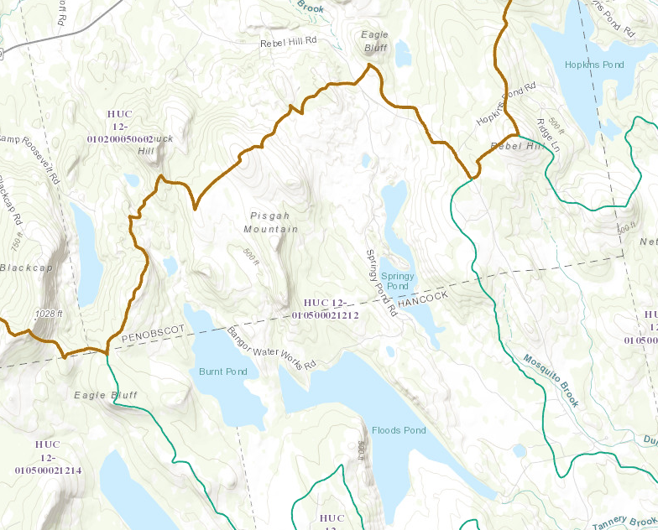
MEGIS Watershed Map Showing City of Bangor Water Supply: Floods Pond
ANALYSIS
Trends
Due to extensive efforts in the urbanized areas, people have a much higher level of situational awareness regarding water quality over the past ten years. Almost no land development occurred except for the Pisgah Mountain wind turbine project. Most shorefront development are upgrades from seasonal dwellings to year around. These upgrades almost always involve new septic systems and more effective erosion control measures. Large yards are out of fashion due to high maintenance in general; lack of larger lawns reduces fertilizer and related pollutants. New state regulations regarding forest harvesting and much less forest harvesting are reducing the impacts of those practices.
Protective Measures
The CLUO contains extensive protective measures to ensure management and preservation of water resources. In terms of surface waters, several ponds in Clifton are quite remote and human use is quite minimal with almost no development.
Local Water Resource Sustainment
The public survey indicates keen interest in natural resources. The Planning Board should keep this in mind when they consider development in shore land areas as well as future reviews and revisions in the CLUO.
Clifton is no different than other areas with regard to being subject to natural calamities as well as from time to time, the mischief of humans. Local government should consider contingency plans for water bodies and resources most importantly when there will be a substantive economic impact from the loss of use. This might include contingencies for dam failure for the structures discussed above controlling water levels at Parks Pond and Chemo Pond, for example.
Because Clifton has a heavy forest cover type, it is also possible significant forest fire could entirely destroy a community around one of the lakes resulting in sustained reduced tax revenue for several years not to mention planning procedures and actions about re-building.
POLICY AND IMPLEMENTATION PLAN
In order to protect the quality and manage the quantity of the State’s water resources, including lakes, aquifers, great ponds, estuaries, rivers and coastal areas; protect the State’s other critical natural resources, including without limitation, wetlands, wildlife and fisheries habitat, sand dunes, shore land, scenic vistas and unique natural areas; and safeguard the State’s agricultural and forest resources from development which threatens those resources, the Town of Clifton has developed the following policies and implementation strategies:
The Town previously identified and continues to restrict development in areas immediately adversely impacting water resources and regulates development townwide in a manner mitigating or minimizing impacts through the CLUO. The CLUO includes detailed maps regarding the location of water resources.
The Planning Board and Code Enforcement Officer should look more carefully at re-building requirements along shorefront property and establish a clear timeline for re-building efforts if disaster strikes – fire, storm, or other unexpected situations. Sometimes it may take law enforcement and insurance companies long periods of time to resolve issues – longer than the CLUO dictates. It might be wise to start the re-building clock the day the law enforcement determines the outcome of the fire (arson or not for example). Another consideration may have some tie to insurance settlements. This topic is one of importance for the property owners, the town (in terms of taxation), and uniform enforcement of re-building rules. Due to the small size of some lots and the building restrictions, this is not inconsequential.
The Code Enforcement Officer identifies failing subsurface wastewater disposal systems and works with the town to apply for state assistance funding for those in need.
The Code Enforcement Officer and Planning Board should be more proactive providing residents with educational materials about the effects of and prevention of nonpoint source pollution.
The Town Office should maintain informational material about the salt-water aquifer near Chemo Pond - mostly along portions of Scott Point Road.
The Town should work with the newly forming Chemo Pond Lake Association to ensure maintenance of the water level ensuring it remains good for recreation and habitat. (Endorsed by the public opinion survey.)
The Board of Selectmen should encourage the formation of a Volunteer Lake Monitoring Committee to work with the training and assistance of the Maine Volunteer Lake Monitoring Program.
The Board of Selectmen, or their designee(s), should approach the neighboring communities of Bradley, Eddington, Mariaville, Holden and Otis, who share water resources, to jointly prepare phosphorus loading calculations for great ponds within the Town.
The Town should evaluate potential impacts (wildlife, recreational, financial, etc.) from hazards and emergencies that may affect water resources. This would include development of a risk model identifying such incidents as fuel spills (for example, a fuel spill on Route 9 into Parks Pond); dam failure (Parks Pond and Chemo Pond); prolonged droughts.
The Town should ensure water resource protection using best management practices as part of road or other municipal maintenance or construction efforts.
WATER QUALITY PROTECTION FINANCIAL RESOURCES
Below is an abbreviated listing of water protection funding and assistance programs and descriptions of those programs.
Small Community Grant Program
The Small Community Grant Program provides grants to towns to help replace malfunctioning septic systems that are polluting a water body or causing a public nuisance. Grants may fund from 25% to 100% of the design and construction costs, depending upon the income of the owners of the property, and the property’s use. An actual pollution problem must be documented in order to qualify for funding. The highest priority are problems polluting a public drinking water supply or a shell fishing area. DEP grants are not available to provide septic systems for new homes, and any home constructed since October, 1974 must show evidence that a septic system was previously installed which complied with the Maine Subsurface Wastewater Disposal Rules. Submit grant applications by the municipality in which the property owner resides. Check with the state to determine the schedule for grant submissions.
Maine State Revolving Loan Fund (SRF)
The SRF provides low interest loans to municipalities and quasi-municipal corporations such as sanitary districts for the construction of wastewater facilities. The SRF is funded by a combination of federal capitalization grant and state bond issue funds equal to 20% of the federal grant. State bond issues are approved by the voters in the State of Maine. The Maine Municipal Bond Bank (MMBB) is the financial manager for the SRF program. The MMBB combines federal and state funds with MMBB bond funds to create attractive interest rates; 2% below the market rate.
The DEP Division of Engineering and Technical Assistance (DETA) administers the technical aspects of the program and the projects funded by it. The primary purpose of the fund is to acquire, plan, design, construct, enlarge, repair and/or improve publicly-owned sewage collection systems, intercepting sewers, pumping stations, and wastewater treatment plants. The long-term goal of the SRF is to establish a self-sufficient loan program that will maintain and improve Maine’s inventory of municipal sewage facilities in perpetuity. This will ensure preservation of the water quality gains that were realized by the initial construction of them.
State law also gives the DEP flexibility, through the related Construction Grant Program, to use bond issue funds with other sources of funding to provide affordable financing of municipal and quasi-municipal wastewater facilities. The Board of Environmental Protection has established a goal for residential users of 2% of the Medium Household Income (MHI). The DEP attempts to reach this goal by combining grant funds, SRF loan funds, and other sources of funds such as Community Development Block Grants, Rural Development loans and grants, and grants or loans from the Economic Development Administration.
State participation is limited to 80% of the project costs for wastewater treatment facilities, interceptor systems and outfalls. The word “expense” does not include costs relating to land acquisition or debt service, unless allowed under federal statutes and regulations. The commissioner is also authorized to grant an amount not to exceed 25% for preliminary planning or design of a pollution abatement program.
Watershed Protection Grant
Teachers or Advisors of grades 6 through 12 can apply for a maximum of $1000 for support of a service-learning project. Teachers are responsible for obtaining the appropriate permission from their school or school board before applying. Preference will be given to schools who involve community members and in-kind matches of plants or other materials that will be used to control erosion or storm water run-off or moderate temperature (streams only). Cost sharing with landowner is highly encouraged if project is on private land. Funds can be used for materials to restore or improve the site, to transporting students to the site, for a sign at the site and for expendables related to public education.
Action Projects must restore or protect a local freshwater resource (lake or stream that feeds a lake), to be named in the application. Projects must involve lake or stream watersheds; no purely coastal applications can be funded. The focus of this program is to protect water quality of a lake or stream and to educate the public about the relationship between land use and water quality. Projects should prevent soil erosion; reduce polluted storm water or moderate temperature (streams only). A typical project would begin with classroom activities that help the students learn about the habitat, followed by a field survey, and culminate in a service learning project such as planting of a vegetated buffer, repairing eroded shorelines, ditches, or roads.
Public Education projects will educate the public about the knowledge gained through the classroom watershed protection project. Some examples would be publishing articles by students in local newspapers, hosting a public event at the site upon completion, conducting a workshop to teach others in the community or lake association about how to complete a similar project on their property, and making a presentation to the conservation commission or other municipal group that has the authority to make changes to protect the lake or stream watershed.
Surface Water Protection Projects
Maine has thousands of surface water bodies such as lakes, ponds, rivers, streams, and coastal waters within its boundaries. Many of them are adjacent to or near highways. To help reduce pollution and other damage from those highways, the Maine Department of Transportation has created a Surface Water Quality Protection Program (SWQPP). This program is funded under the Surface Transportation Program (STP), which is part of the federal Transportation Equity Act for the 21st Century (TEA-21) of 1998.
The funding can be used on what MDOT refers to as arterial, major and minor collector highways, which include most of the major highways in Maine. The SWQPP has two purposes. First, to identify potential project locations where surface water quality is being adversely impacted by runoff from highways, and, second, to select and prioritize potential pollution elimination projects for funding under this program.
Working with the Department of Environmental Protection, MDOT has developed a list of thirteen criteria for evaluating potential projects. That list includes requirements that work funded under this program not involve non-MDOT property unless it is essential to eliminating runoff pollution, that projects consist of actions not included in normal routine highway maintenance or construction activities, and that high priority be given to projects which are actively supported by the municipality, local environmental groups, conservation commissions, planning boards, soil and water conservation districts and similar groups.
Nominated projects are screened, selected and prioritized by a team of representatives from MDOT, the Maine Department of Environmental Protection and the Federal Highway Administration. While there is no deadline for applications to be considered, they will be reviewed and selected in the order in which they are received, so the earliest submissions will have an advantage.
Nonpoint Source (NPS) Water Pollution Control Grants
The primary objective of NPS projects is to prevent or reduce nonpoint source pollutant loadings entering water resources so that beneficial uses of the water resources are maintained or restored. Maine public organizations such as state agencies, soil and water conservation districts, regional planning agencies, watershed districts, municipalities, and nonprofit (501(c)(3)) organizations are eligible to receive NPS grants.
This program invites proposals for the following three types of NPS projects:
NPS Watershed Project. This project is designed so that BMPs are implemented in a manner that leads to a significant reduction in NPS pollutant load to a waterbody. The load reduction is intended to restore or protect water quality.
NPS Watershed Survey. This project focuses on finding, describing, and prioritizing NPS pollution sources in a watershed, and recommends BMPs for correcting identified pollution sources.
Watershed Management Plan Development. This project is to develop and produce a locally supported “Watershed Management Plan.” The plan is intended to be a comprehensive plan of action to prompt use of BMPs to prevent or abate NPS pollution sources within a watershed or Sub-watershed.
Wellhead Protection Program
In 1991, the Maine Drinking Water Program (DWP) began the process of developing and implementing a wellhead protection program for all of the public water supplies statewide. This included all of the community, non-transient non-community and transient non-community water systems. Nearly all of the community and non-transient non-community systems have completed self-evaluation forms designed to familiarize operators with the threats their system faces, and to provide the drinking water program with the information required to evaluate the level of risk present at each source (source water assessments).
Completion of a self-evaluation form is considered as satisfying the first two steps in a complete wellhead protection plan, delineation of the protection area and an inventory of potential sources of contamination. Therefore, systems that have successfully completed these self-evaluations are halfway to completing wellhead protection plans. The next steps will be for systems to complete management and contingency plans, which will be requested after the Source Protection Section completes assessments for each well.
A community and non-profit non-community public water systems can apply for a grant of up to $5,000 to plan or implement projects designed to protect their groundwater supply from contamination. Projects such as the development or implementation of a wellhead protection plan, developing public educational materials, or developing useful base maps are eligible for funding. All projects are evaluated and ranked based on several specific criteria and awards will be made beginning with the highest ranked project and working down the list until all grant funds are exhausted. In general, projects with a demonstrated need, which build on previous source protection work, and which involve other municipal or volunteer partners are more likely to be approved.

