SELECTBOARD MEETING MINUTES
January 27th, 2023

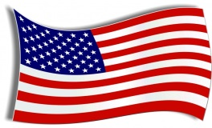Flag Salute 4:00PM

CALLED TO ORDER: Geoff Johnson called the meeting to order at 4PM

ROLL CALL: Board Members – Geoff Johnson, Bill Rand, Lee Bryant, Gerald Folster & Gary Ferrill Present All present
Administrative Assistant- Deborah Hodgins – Present

New Business:

Sign warrant for Public Hearing set for February 8th, 2023
Lee made the motion to sign Warrant as written.
Lee/Geoff 5/0

Adjourned: 4:10
By: Geoff/Lee 5/0

Approved at the March 7th Sel Brd meeting

